Education and country growth models
Part II
Modelling optimal prioritisation across levels of education in the country development process

Martin Anders Gustafsson

CONTENTS FOR PART II
7 INTRODUCTION FOR PART II 186
8 HOW EDUCATION POLICYMAKERS DEAL WITH PRIORITISATION ACROSS EDUCATION LEVELS 188
9 THE ECONOMICS OF PRIORITISING ACROSS EDUCATION LEVELS 192
9.1 The basic economic theory 192
9.2 Empirical findings from cross-country models 196
10 NEW FINDINGS FROM THE COUNTRY-LEVEL DATA 201
10.1 The data 201
10.2 Methodology 204
10.3 Cross-sectional analysis of recent values 204
10.4 Analysis of historical trends 212
10.5 Growth and education prioritisation patterns 223
10.6 Guidance for a country’s policymakers 230
11 CONCLUSIONS FOR PART II 240
Appendix D 244

Figures and tables
Figure 36: The human capital model and the role of education policies 195
Figure 37: Educational level prioritisation ±2007 206
Figure 38: Magnification of Figure 206
Figure 39: Figure 38 with dispersion illustrated 207
Figure 40: Figure 38 viewed transversally 208
Figure 41: Moving average pathways for enrolment and spending 209
Figure 42: Income and a measure of education development 210
Figure 43: Moving average pathways without use of income 211
Figure 44: Figure 43 with absolute per student spending 212
Figure 45: Education levels in 2007 and 1973 214
Figure 46: Historical trends for education indicator (parametric) 217
Figure 47: Magnification of Figure 46 218
Figure 48: Lowess curves for historical indicator trends against income 220
Figure 49: Magnification of Figure 48 220
Figure 50: Lowess curves for just 2000 and beyond 221
Figure 51: Magnification of Figure 50 221
Figure 52: Sub-Saharan Africa’s prioritisation of education levels I 222
Figure 53: Sub-Saharan Africa’s prioritisation of education levels II 222
Figure 54: Educational level prioritisation ±2007 by growth category 224
Figure 55: The SSA region and spending on tertiary education 226
Figure 56: Lowess curves for historical trends by economic performance 227
Figure 57: Added variable plot for spending on secondary students 229
Figure 58: South Africa gross enrolment ratio values 231
Figure 59: South Africa UIS education expenditure indicator values 232
Figure 60: South Africa UIS vocational secondary education enrolment values 232
Figure 61: Educational level prioritisation in South Africa 2009 236
Figure 62: Average pathways with South African points 237

Table 23: Simulations from regression using IIASA-VID data 199
Table 24: ISCED classifications 201
Table 25: Data availability 202
Table 26: Regression of indicator values on income 205
Table 27: Coefficients of variation for enrolment and spending statistics 207
Table 28: 1978-2012 country classification changes I 213
Table 29: 1978-2012 country classification changes II 214
Table 30: Education levels in 2007 and 1973 215
Table 31: Regression of indicator values on historical income 216
Table 32: Regression of indicator values on income and decades 219
Table 33: Indicator values ±2007 by growth category 224
Table 34: Correlation matrix for LIC and LMC education spending 225
Table 35: BACE regression outputs – growth on UIS and other data 228
Table 36: South African gross enrolment ratios from household data 233
Table 37: Calculating South African per student spending ratios 235
Table 38: Total spending patterns for South Africa 238
Table 39: Levels of education data by country 245

- INTRODUCTION FOR PART II
Part II of the dissertation addresses the following question: What new patterns can be found in the historical country-level enrolment and per student spending data to inform policymakers on how to prioritise the various levels of the education system? It will be argued below that given the importance of this question to policymakers, and the data that are available, not enough work in relation to the question has occurred. Some related modelling using country-level data has occurred and this will be discussed. However, what has been largely absent is rigorous analysis of a rather well-known data source, the data of the UNESCO Institute for Statistics (UIS), gathered over several decades from ministries of education around the world. The analysis presented below focuses above all on the enrolment and per student spending statistics, by education level, from this data source, going back to 1970. It moreover explores correlations between the education values and economic growth values.
Why is the question an important one? The circumstances of each country are different and there can clearly be no one-size-fits-all prescription relating to, for instance, what average public spending per student should be at the primary, secondary and tertiary levels for countries at different levels of development. Yet cross-country patterns can be useful insofar as they highlight when country-specific patterns are anomalous and might therefore be problematic and in need of an adjustment. The patterns can thus be suggestive. Currently the data analysis available to inform across-level prioritisation in education is sparse. The same can be said about the available theory. Policymakers have considerable decision-making power with respect to how public spending is spread across the levels of the education system. It is in this area that policymakers are likely to be particularly interested in analysis relating to the above question. Even with respect to the spread of enrolments across levels of the system, policymakers exert considerable influence, though arguably less so than in the case of public spending. Governments can increase or restrict the supply of student places at education institutions, though restrictions often result in serious public resistance and increasing supply may not result in actual enrolment increases if the demand for education is insufficient or there are quality bottlenecks, for instance insufficient graduates of the required standard exiting from a lower level.
Section 8 below proposes a set of factors which are likely to influence decisions relating to prioritisation across levels amongst policymakers. This examination includes some discussion of how policymaking processes work and how decisions are taken when there is little empirical evidence. It also includes discussion of how the microeconomic evidence on rates of return to education has to some extent been misinterpreted in the context of prioritisation across levels. Section 8 thus provides an institutionally-focussed examination of how decisions seem to be taken, which then forms a backdrop against which to explore, in the next section, more data-driven decision-making frameworks.
Section 9 looks at what the existing theory and empirical evidence in economics has to offer the policymaker faced with level prioritisation decisions. On the theory side, human capital theory, rates of return to education and models of country development receive attention. Modelling by Vandenbussche, Aghion and Meghir (2006) of OECD country data is examined, as is related work by Lutz, Cuaresma and Sanderson (2008) focussing on developing countries.
Section 10 begins by describing the UIS enrolment and expenditure data used for the new analysis, including the shortcomings of these data. Key shortcomings worth noting at this point already are the absence of reliable and comprehensive values on participation in or expenditure on pre-school and vocational training. The analysis thus focuses largely on relationships and trade-offs between the three large categories: the primary, secondary and tertiary levels. In fact, much of the emphasis in the analysis falls on the secondary and tertiary levels, as this is where policymakers have most discretion. Universal participation in primary schooling is generally considered an a priori policy priority, though expenditure per primary student is a more debatable matter. A discussion of the basic line of inquiry and the kinds of data analysis techniques employed follows. The analysis itself includes fairly basic descriptive analysis as well as some multivariate modelling. As will be seen, the data do not lend themselves to the identification of cause and effect. However, they do allow for the identification of associations which, it will be argued, are suggestive of actual historical dynamics and thus important for policymakers. It should be remembered that despite the fact that the UIS data are well-known amongst researchers and policymakers, they appear not to have been subjected to the kind of pattern-seeking analysis presented in section 10. Key findings include the fact that countries with faster growing economies have pursued different enrolment and education spending trajectories and, somewhat unexpectedly, a high positive correlation, even when controlling for a large range of non-education variables, between higher per student secondary school spending in the past and faster growth. In keeping the other two parts of the dissertation, the analysis focuses strongly on concerns that policymakers in developing countries would have, including policymakers in South Africa. Section 11 concludes Part II of the dissertation.
- HOW EDUCATION POLICYMAKERS DEAL WITH PRIORITISATION ACROSS EDUCATION LEVELS
Education policymakers, and government policymakers in general, do to some extent actively influence how the various levels of the education system are prioritised, through funding decisions taken and the design of policies relating to matters such as entrance requirements, compulsory school attendance, and exit qualifications. At the same time, prioritisation across levels occurs partly through dynamic social and economic processes over which the policymaker has little direct influence. Below, six factors which are likely to influence how prioritisation occurs are discussed: available public funding; public demand for education; demands of employers; teacher union demands; international pressure; welfarist considerations. The first five factors are powerful external factors over which the policymaker is likely to have limited control, though how exactly these factors shape policies is still largely under the control of policymakers. The sixth factor is essentially economically-informed rational decision-making and is thus considered an optimal factor. The greater the degree to which prioritisation decisions are based on theories encompassing rational notions of efficiency, equity and country development, and the greater degree to which these decisions are based on empirical evidence, the better. The discussion of the six factors will point to certain complexities, including dynamics between the six factors and the fact that what may look like a rational pursuit of welfarist principles, may instead be something else.
(a) Available public funding. Public funding constraints limit the possible size of the education system as a whole. However, these constraints tend to be felt most acutely at the tertiary and to some extent secondary levels, because per student costs tend to be higher the higher the level (as seen in section 10). Moreover, any discussion of limiting in the size of the system due to funding constraints is likely to focus on, firstly, the tertiary level and, secondly, the secondary level, as limiting expansion at a higher level has only a limited effect on lower levels, whilst the reverse does not apply. In developed countries, it is the relatively high availability of public funds that has been a key factor in the achievement of extremely high enrolment ratios at all levels, making universal tertiary education appear as a possibility (Schofer and Meyer, 2005: 898).
(b) Public demand for education. Policymakers, in particular within democratic societies, are likely to be under pressure to expand access at whichever level universal coverage has not been reached to satisfy demands from citizens wishing to maximise their future incomes. At the primary level, but even at the secondary level, this pressure may take the form a constitutional provision making education a human right. However, not all popular pressure is oriented towards social equity. In less equal societies, an elite may create pressure for public funds in education to be largely directed towards this elite. Verspoor and Bregman (2007: 6), in a report produced for the World Bank, argue that this has been the case in Sub-Saharan Africa, insofar as elites have lobbied for the maintenance of elitist secondary school systems with high per student spending and relatively low coverage. One argument elites may use against a rapid expansion of the education system is that this reduces not just the average quality of graduates, but even the overall number of graduates achieving at a high level, through a dilution effect. The empirical evidence for such an effect is not strong, however, as argued in for instance Taylor and Spaull (2013).
(c) Demands of employers. Policymakers are influenced by the needs of employers, including the government as an employer, in a number of ways when plans are made to prioritise certain specialisations or expand particular levels of the education system. However, as Bertrand (2004: 71) argues, in a planning manual of the International Institute for Educational Planning (IIEP) directed at policymakers, labour market demands are too frequently ignored, or misinterpreted, in the education planning process. This is partly because, following the discrediting of highly detailed ‘manpower planning’ methods due to problems around the workability of these methods, the development of alternative techniques to promote labour market responsiveness amongst education planners has been weak. There has been, to some extent, a methodological vacuum. Yet there are large differences between the approaches of different governments, with some paying very little attention to labour market demands and others setting up sophisticated information and knowledge systems that at least improve the probability that education planners will understand what the labour market demands are. An example of the latter would be the Occupational Outlook Handbook (OOH) produced periodically by the Bureau of Labor and Statistics in the United States. The OOH includes a database, which can be queried online, covering over 1,000 occupations and providing statistics on projected growth in each occupation. For instance, ‘high school teachers’ require a Bachelors qualification and their demand is expected to increase by 7% between 2010 and 2020, the time horizon of the OOH forecasts (http://www.bls.gov/ooh/, accessed July 2013). The occupation ‘construction labourers and helpers’ requires no formal qualifications, though certain basic skills are needed, and here demand to 2020 is expected to increase by 23%. Clearly this information can guide education planners directly, though it is also intended to steer public demand for education. The United Kingdom’s equivalent of the OOH, the Working futures report, also uses a ten year horizon but is more analytical, providing for instance forecasted trends with respect to the demand for graduates at different levels of the education system (United Kingdom: UK Commission for Employment and Skills, 2011: 120). However, Bertrand (2004: 44) suggests that even in the UK, the utilisation of this kind of information is limited. In South Africa, the Human Sciences Research Council (HSRC) has produced two issues of the Human resources development review, in 2003 and 2008, partly to provide research to education planners on labour market demands (Kraak and Press (eds.), 2008). There is little evidence that the HSRC’s reports are used as such reports should be in education policymaking in South Africa. The reasons for this could of course be both a lack of responsiveness in the education sector and limitations of the reports themselves.
(d) Teacher union demands. Teacher unions demands for higher salaries at the primary and secondary school levels, where unionisation is typically strong and market forces weak, are likely to crowd out funding for post-school education, where unionisation tends to be relatively weak. In fact, evidence from several developing countries presented by Pritchet and Filmer (1997), and discussed in Part I of the dissertation, suggests that this kind of crowding out could be the norm as teachers mostly succeed in inflating their salaries to a point well above a more market-related level.
(e) International pressure. Part III of the dissertation discusses briefly the way foreign and international donors play a large role in the education decision-making of a specific set of developing countries. Researchers such as Samoff (1999) have been highly critical of this kind of pressure, including the way in which it has apparently led to an over-prioritisation of primary schooling at the expense of the higher levels of the system. The basic argument is that donors tend to over-simplify and misunderstand the dynamics of the recipient country and hence advocate and generally succeed in imposing inappropriate policies. How rates of return analyses have been misused, in particular by World Bank analysts advising Sub-Saharan African governments on how to prioritise education levels, is a matter that has received considerable attention in the literature. This is discussed towards the end of this section. As is shown in the data analysis of section 10, however, the movements in the key enrolment indicator values since 1970 do not clearly support the hypothesis of a perverse over-prioritisation of the primary level in the case of Sub-Saharan Africa.
(f) Welfarist considerations. Finally, more skilled policymakers take the five factors mentioned above and incorporate them into what can be called a welfare economics framework, even if not all policymakers would be happy to use this term. Essentially, this involves looking at what kind of prioritisation across the education levels would maximise future welfare, whilst recognising that optimal future welfare is to some degree subject to differing interpretations of social equity. Educational equity is likely to promote income and socio-economic equity, but at the same time using education to create a critical mass of talented experts, which inevitably involves allowing some inequity, can promote innovation and thus economic growth. Of course the analysis can occur in a more or less formal manner. Moreover, the use of empirical evidence is in itself not proof that good evidence-driven policymaking is occurring. The evidence should be correctly interpreted. It is not impossible that optimum decisions will be taken even in the absence of a rational planning approach characterised by sound interpretation of empirical evidence. Responding very directly to, for instance, the demands of the public may result in an optimal distribution of education funding across levels. However, it can be considered preferable to pursue optimum policies on the basis of a approach model, as opposed to hoping that optimum policies will be achieved by accident.
In any policymaking process, it is particularly important to avoid what is referred to as ‘piecemeal welfare economics’ by Lipsey and Lancaster (1956: 11), two economists who came up with the first formal definition of ‘second best’ policymaking. In this type of policymaking, one explicitly acknowledges that a Pareto-optimal economy may be rendered impossible by a constraint, generally a market imperfection, which is not removable. For instance, an optimal set of enrolment ratios and per student spending values may involve a tertiary enrolment ratio of x and tertiary per student funding of y. However, teacher union pressure may result in a crowding out of the tertiary level in the budgeting process and policymakers may respond by suppressing per student funding at the tertiary level to a point below y, whilst maintaining tertiary enrolments at x. Because of the constraint imposed by teacher unions at the primary and secondary levels, the optimal policy positions at the tertiary level no longer hold true. Either x or y, or both, stipulated in the ‘first best’ solution must be abandoned. Haphazardly reducing per student spending could represent ‘piecemeal welfare economics’. However, rationally determining how to achieve a sub-optimal deviation from both x and y would represent second best policymaking.
Turning to the problem of rates of return to education and their implications for prioritisation across education levels, in Part I arguments put forward by Glewwe (1996) were discussed briefly. His two key complaints around the way rates of return have been used are, firstly, that the exclusion of positive externalities within these rates results in an under-valuation of tertiary education and, secondly, that the years of schooling variable used in the calculation is a poor proxy for what people actually learn, meaning there is a serious and confounding measurement error in the calculation. Bennell (1996) offers further reasons for rejecting the way rates of return have been used to inform policy, in an article titled ‘Using and abusing rates of return’. He argues that apart from possible problems with the source data, very basic anomalies in the rates of return calculations done by Psacharopoulos (2004) have been overlooked. He also argues that adjustments that ought to occur to typical rates of return statistics to take into account issues such as innate ability, socio-economic status and opportunity costs associated with informal sector work, would tend to reduce the primary level rates of return statistics to a larger degree than the tertiary level statistics. Gustafsson and Mabogoane (2012: 353) emphasise that rates of return, even in the absence of measurement errors, would tend to reflect the dynamics of a sub-optimal education system, and implicitly reject an approach where planners do not consider what the rates of return might have been in the presence of more efficient policies. Specifically, they link the high rates of return associated with attaining grade 12 in South Africa to the fact that grade 12 is where the schooling system’s only national examination exists. The policy priority should perhaps rather be to introduce additional examinations lower down in the schooling system, as opposed to simply prioritising grade 12 attainment on the basis of existing rates of return.
There appears to be no published attempt to come up with a theory on how rates of return, with all their shortcomings, could be used to inform education policymaking, in particular prioritisation across different types and levels of education. Whether such a theory is possible and could assist policymakers is not clear. Any theory would need to take into consideration the key dynamics discussed above, such as positive externalities associated with higher levels of education. It would also need to move beyond simply asking which level of education to prioritise. It seems preferable to see the problem as one of an equilibrium. Enrolment growth and spending increases must probably occur across several levels of the system at once, so questions should focus on how to pursue an optimum spread of budgets and efforts across several competing priorities. The analysis provided in section 10 can be considered a contribution towards a more evidence-based and rational approach to prioritisation across education levels, even if it falls several steps short of comprising a neat and comprehensive theory.
- THE ECONOMICS OF PRIORITISING ACROSS EDUCATION LEVELS
  - The basic economic theory
Figure 36 below presents a diagram depicting the theoretical framework for investment in education by households and the government. The framework represents a fairly standard picture of the human capital model, with some differentiation by education level added (Schultz, 1961; Boissiere, 2004). A diagram such as this could be of use for education policymakers wanting to organise the discussion around the prioritisation of the levels of the education system, where the ultimate aim is to advance economic growth, or national development. The diagram can also be considered a summary of various strands of theory that are discussed across the three parts of the dissertation.
A useful point of departure is the decisions taken by the household to invest in the education of its younger members. Investment decisions here are influenced by a number of variables. The household perceives, perhaps inaccurately, what incomes are associated with specific years of schooling and qualifications. These perceptions can encourage investment in more education, depending on the income gained from the additional education relative to the income forfeited from not entering the labour market immediately. The latter is often referred to as the indirect or opportunity cost of education. High direct costs, in the form of for instance tuition fees, could dissuade the household from investing further in education. The decisions of the household carry considerable risk, for two key reasons: it is risky to use present information as a proxy for what future incomes will be and the household cannot know if its members will succeed in reaching achievement levels required for specific qualifications. Investment in primary and secondary schooling often occurs due to the option value of this level of schooling, or the fact that it makes higher levels of education an option at a later point in time.
The education system gives household members two key things: learning outcomes, in the form of skills and knowledge, and qualifications. Importantly, learning outcomes are brought about not just by what happens in the education system, but also by what happens in the household. The greater the schooling, or human capital, of the previous generation of scholars in the household, or the parents, the greater the contribution of the household towards the learning of the next generation. Education makes people more productive, which contributes to higher incomes. However, success in the labour market also depends to some degree on qualifications, which provide signals to employers, and allow employers to screen job seekers. In theory, qualifications would reflect the skills and level of productivity of job seekers, though in practice the signalling devices would be imperfect. For instance, people with the same qualification would possess different innate abilities. It is possible for less qualified people to be more productive than more qualified people if, for instance, the qualifications system itself is inconsistent or unqualified people have acquired skills outside the formal education system.
Economic growth and social development occur as aggregate income rises, but also as positive externalities arising out of a more educated society, for instance greater trust and social cohesion, are realised. There is a cycle of improvement as each generation uses some of its income and capabilities to ensure that the next generation attains an even better level of education. A key question is how governments and policy can accelerate this cycle of development, or perhaps undermine it. This is dealt with in the grey boxes of the diagram.
Government can accelerate human capital accumulation by ensuring that the redistribution of income, through the tax system, manifests itself in subsidised education for the poor. This redistribution plays a particularly large role in promoting growth in the lower levels of the education system, specifically primary schooling. Virtually everyone, regardless of socio-economic status, is able to participate in primary schooling. In contrast, home background disadvantages are a key reason why many are not able to fulfil entry requirements for tertiary education institutions. Moreover, due to high private returns to tertiary education, private loans for this level of education are, at least in theory, relatively easy to obtain, even for the poor who have performed well at the secondary level. In reality, however, poorly functioning banking sectors in developing countries may make it difficult for these loans to be realised. The fact that the cost of educating each primary school child is relatively low, is a further motive for a government to subsidise, often fully, primary school education for all. In fact, governments will often subsidise even the primary schooling of the rich, who could afford to pay for this schooling through private means. There is no strong economic rationale for any government to do this, but an ideological concern to keep all of society within one public primary system is often the determining factor here. Governments will often enforce investment in primary schooling through compulsory education laws. The enforcement applies particularly in the case of the very poorest households, which might otherwise have benefitted economically from having their young children work for an income, or in a family business or farm. Again, the overriding influence here may be ideological, rather than purely economic. Primary schooling has come to be seen as a non-negotiable basic human right or, to use the more economic terminology, a merit good.
Due to the very public nature of the education system, prices are often not determined through market forces, but administratively, which increases the risk of rent-seeking (capture of income beyond what can be justified by one’s productivity) and inefficiencies. A large policy challenge revolves around the determination of teacher salaries in the pre-tertiary schooling sector, whose structure lends itself to high levels of unionisation and thus a combination of monopoly (a union will represent all teachers) and monopsony (the state is the only buyer of services). The government needs to ensure that the monopolistic result of inflated prices (or salaries) or the monopsonistic result of deflated prices are avoided. This needs to be achieved to a large extent through an analytical process of comparing teacher productivity and the wages of teachers relative to those of other similar professionals. These kinds of problems are relatively absent at the post-school level, largely because university teachers tend to have skills which are in demand in various sectors of the economy, thus allowing for roughly a market-like determination of wages.
Governments typically need to find innovative ways of enhancing productivity in the education sector, given the serious information asymmetry problems that are inherent to the education sector. The clients, households, are often unable to understand the quality of the specific education they are investing in until it is too late, in other words when the scholar enters the labour market. Even the government experiences great difficulties in assessing whether learning outcomes could be increased with the given budgets and technologies. Accountability systems are needed, but these should be designed in such a way that they minimise the possibility of gaming, in particular the possibility that teachers will misinform the administration about performance in their institutions. Incentives and disincentives can be attached to accountability systems, but unless this is done carefully, it can encourage even more misinformation. Moreover, poorly designed incentives can create unintended disincentives if, for instance, they result in a sense that the administration treats teachers unfairly.
The government can reduce the information asymmetries experienced by the household in two important ways. Firstly, it can ensure that the household receives good information about the educational performance of its scholars, through standardised assessment systems. Not only does this assist the household in determining whether it is worth educating the scholar further, this information also allows the household to become an agent in the education process. An informed household is able to complain about the quality of the education service, may be in a position to consider alternative schools and might, together with other households, exert political pressure on the school to perform better.
Secondly, the government can make it clearer to the household what level of income is associated with different types of education, especially at the post-school level, where the heterogeneity of educational offerings can be confusing. It can do this by collecting data and publishing the average earnings of graduates from different fields of study and institutions.
Just as the government can enforce investment in primary schooling in the interests of combating poverty and advancing economic growth, it can also prohibit the household from investing in education where this seems like a poor investment. It does this through a system of quality hurdles, often in the form of examinations, which prevent scholars from advancing further in the education system if they are considered unable to succeed at the next level, or within a specific field of study.
What has been provided here is a high-level summary of key dynamics that should influence the education planner’s thinking around the prioritisation of the various levels of the education system. Clearly, the amount of education that happens at each level, in terms of enrolments and learning outcomes, is not a simple matter of spreading budgets across the levels in a manner that is appropriate for the country’s level of economic development. Various interventions aimed at improving the education system’s internal efficiency, setting standards and making information available interact with each other and determine the effectiveness of each level, and of the of education system as a whole.

Figure 36: The human capital model and the role of education policies
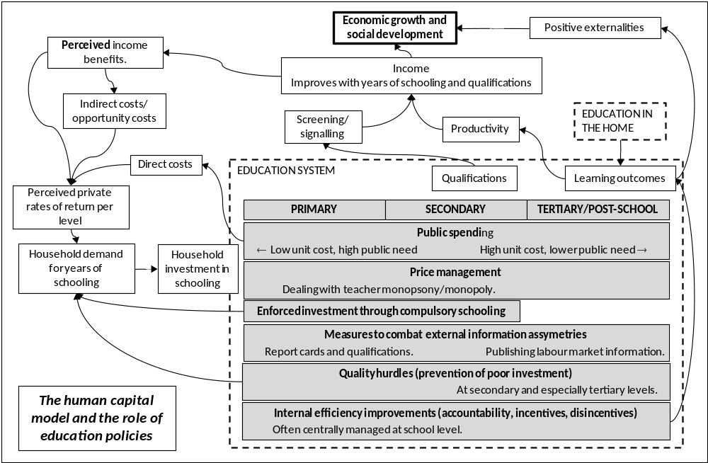
  - Empirical findings from cross-country models
As discussed in section 8, the use of the microeconomic rates of return to education evidence to inform prioritisation across levels of the education system has been flawed. It is not clear whether the existing flaws in this channel between evidence and policymaking can be corrected, but this is not the focus of this dissertation. Instead, the focus in the dissertation is mainly on the use of cross-country data in answering policy questions. Part II pays special attention to how these data can be used to solve policy questions relating to the prioritisation of education levels. Here there seems not to be much empirical work done beyond the few texts discussed in this section. Two of these texts are discussed in some detail as their coverage of the policy questions is rather comprehensive: Vandenbussche, Aghion and Meghir (2006), who focus just on high income countries, and Lutz, Cuaresma and Sanderson (2008), whose focus is developing countries. At the end of the section, a few further texts are briefly discussed which deal less comprehensively with the question posed at the start of section 7, or limit their attention to specific geographical regions.
Vandenbussche, Aghion and Meghir (2006), henceforth referred to as VAM, present a series of growth regressions which are unusual insofar as they focus on optimal mixes of levels of education in the labour force. Their theoretical framework was discussed in Part I of the dissertation. Here their empirical work is discussed. VAM are largely motivated by a need to respond to Krueger and Lindahl (2001: 1119, 1130), who found that average years of schooling of adults was not correlated with economic growth in models covering just high income countries, and hence concluded that education was a less important driver of growth in these countries than was commonly thought. This explains partly why VAM use only data from high income countries, specifically 19 high income OECD countries. Further reasons for this are the limited nature of certain data from developing countries, in particular historical public expenditure data and average years of schooling attained data, and the fact that VAM were interested in examining trade-offs between imitation and innovation, the second of these phenomena being a feature largely of developed countries. Despite the exclusion of developing countries, the analysis presented by VAM would probably be of interest to developing country policymakers, who are often under pressure to pursue innovation, often on the basis of ideological considerations.
A key concept in VAM is distance from or proximity to the global technological frontier. If their model is important for education planning, and they suggest it is, then so is understanding a country’s proximity to the technological frontier. They hypothesise that how close a country is to having internalised all the best available technology at any point in time determines what the optimal split in the labour force between skilled and unskilled workers is. In their empirical analysis, VAM consider workers with post-school education as skilled and those with just school education as unskilled. They furthermore assume that the technology of the United States represents the technological frontier. Distance from this frontier is measured in terms of total factor productivity (TFP), a measure worth discussing in some detail. TFP is essentially a measure of how productive workers and the technologies they use are. In other words, it can be seen as the A of the Cobb-Douglas model discussed in Part I of the dissertation. VAM (2006: 110) define the term as follows: ‘output per adult minus capital per adult times the capital share’. This means that TFP is higher when (1) more adults are workers, (2) workers are more productive given a particular level of technology, (3) the technology used is more advanced and (4) the capital share is higher. The capital share and labour share of an economy together equal one. The capital share is generally calculated as the part of national income that is not paid in the form of wages but instead takes the form of interest income and economic profit (Schneider, 2011: 1). TFP improves when the capital share is higher, if output remains the constant, as this would mean that the ratio of outputs to wages increases. VAM themselves do not elaborate on issues relating to the measurement of TFP, though a discussion in Manuelli and Seshadri (2010) suggests this is not a straightforward matter. Saliola and Seker (2011) use firm data to calculate TFP and find within a group of 27 developing countries Zambia, South Africa and Colombia to be amongst the bottom five countries and Ethiopia, Mexico and Peru to be the top three. Intuitively these rankings are difficult to grasp, suggesting that TFP may not have become a sufficiently robust measure to inform policymakers.
Notwithstanding some doubts around measuring proximity to the technological frontier, as a whole the VAM model does appear to make intuitive sense. In one key growth regression (VAM, 2006: 113, model 5), data from five-year intervals for the period 1960 to 2000, covering the 19 OECD countries, are used in a regression described by the following equation:
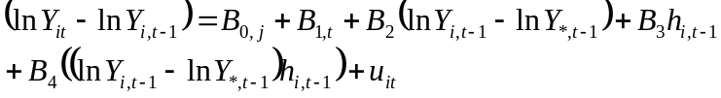 | (86)
On the left-hand side is growth over a five-year period with respect to Y, which in this equation is taken to be total factor productivity. On the right-hand side, fixed effects are introduced for each of seven groups of countries, determined according to institutional and geographical criteria, and indicated by the subscript j, as well as for each time period t. The first slope coefficient describes the association for distance to the technological frontier, lagged by one period, where * indicates that the TFP of the country with the maximum value in period t is used. The variable h is the percentage of adults who have attained a tertiary education. This is lagged by one period. Finally, the last explanatory variable is the interaction of the previous two. All three coefficients B₂, B₃ and B₄ are statistically significant at least at the 5% level. What is not indicated above are three instrumental variables: distance to the frontier lagged by ten years, an indicator of expenditure on tertiary education lagged by five years, and the interaction of these two. The last two of these variables emerge as statistically significant in the first stage regression. VAM conclude, on the basis of a rank test, that endogeneity, specifically the possibility that improvements in Y cause improvements in tertiary attainments, is not a factor that needs to influence the interpretation of the results.
A simulation using the results of the regression indicate that if a country that has incorporated 80% of the technology of the frontier (amongst the 19 high income countries the mean is 74% and minimum 42%) and has achieved 13% attainment of tertiary education amongst adults (mean of 13%, minimum of 1.5%) increases the attainment percentage from 13% to 15%, annual growth improves by 0.1 percentage points. However, had the country incorporated 85% of the technology of the frontier, the same improvement to the attainment percentage would result in an improvement to annual growth of a much larger 0.25 percentage points. VAM (2006: 122) believe the results have policy relevance: ‘Our empirical estimates in this paper can be used to derive policy prescriptions in developed countries’. How exactly this might occur is debatable, but what is clear is that planners stand to gain from improvements to the measurement of the distance to the global technology frontier, as this statistic influences assessments such as whether too few graduates are being produced by the tertiary education sector. The analysis by VAM provides empirical backing for the intuition of education planners, specifically the notion that expanding the tertiary education sector is likely to impact positively on growth, though, as shown by VAM, there is an important conditionality attached to the expected magnitude of the growth improvement. The weakness with the Krueger and Lindahl (2001) argument is thus that their measure of educational attainment was just one average value encompassing all levels of education, and not level-specific values. Disaggregation by level is necessary if the relationship between education and economic growth is to be properly understood. Of course further analysis along the lines of VAM to explore the dynamics in developing countries would be valuable.
In Part I of the dissertation, the IIASA-VID dataset of internationally comparable educational attainment statistics by age, developed jointly by the International Institute for Applied Systems Analysis (IIASA) and the Vienna Institute of Demography (VID) was described. Lutz, Cuaresma and Sanderson (2008) describe a growth regression that uses these data and that probably comes closer than any other available analysis to answering empirically the question of how growth at the various levels of the education system should be prioritised in the interests of country development and economic growth. The analysis has certain drawbacks, which are discussed below, yet it stands out as filling a gap in the body of research required by education planners. Perhaps because the research is still relatively new, but perhaps also due to the unresponsiveness of policymakers, there seems to be little evidence that this research by Lutz et al (2008) has been used or critiqued by those engaged in policymaking.
The growth regression by Lutz et al (2008) uses data from 101 countries, 84 of which are non-OECD countries, for five-year intervals in the period 1970 to 2000. The empirical form of the regression, seen below, is in several respects similar to that of VAM.
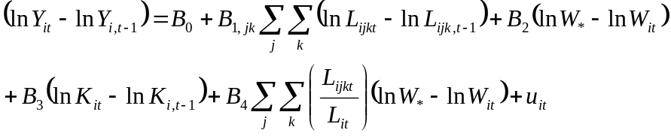 | (87)
Here Y is GDP in real terms, so the left-hand side of the equation refers to GDP growth for country i over a five-year period. On the right-hand side, there is one undifferentiated intercept, so no fixed effects are employed. The first log difference on the right-hand side is repeated eight times, for two broad age categories j, being 15 to 39 and 40 to 65, and four educational attainment categories k, being: (1) no formal education, (2) from incomplete primary schooling to incomplete lower secondary schooling (called ‘Primary’ in Table 23 below and in the original research article), (3) from complete lower secondary schooling to incomplete first level tertiary education (called ‘Secondary’ in the table), and (4) first level of tertiary complete and above (called ‘Tertiary’ in the table). L is the number of adults in each of the eight categories, so the explanatory variables deal with growth in a country’s human capital with respect to the two age categories and the four education attainment levels. The equation includes a distance to global technological frontier variable, as in equation (86), except here the measure is simply the gap between the per capita income, W, of country i in period t and the highest per capita income for any country or period found in the dataset. Growth in the capital stock K is the next explanatory variable. Finally, a series of variables dealing with the interaction between level of L and distance to the global frontier is included.
Of special interest to policymakers would be the simulations, presented by Lutz et al (2008: 1048), for four hypothetical countries, the results of which are reproduced in Table 23. The expected annual growth associated with four different combinations of human capital amongst adults is described.
Table 23: Simulations from regression using IIASA-VID data
Country | No schooling | Highest level attained |  |  | Total | Annual growth
Country | No schooling | Primary | Secondary | Tertiary | Total | Annual growth
A | 50 | 40 | 10 | 0 | 100 | 2.0
B | 0 | 90 | 10 | 0 | 100 | 6.5
C | 0 | 50 | 50 | 0 | 100 | 13.0
D | 50 | 30 | 15 | 5 | 100 | 7.0
Source: Values read off graph in Lutz, Cuaresma and Sanderson (2008: 1048).
Note: See preceding discussion for definitions of the education levels.

As argued by Lutz et al (2008), what seems particularly relevant for policymaking is country C, which illustrates the especially large returns associated with investments in secondary schooling, remembering that this has been defined as ranging from attainment of complete lower secondary schooling to incomplete first level tertiary education. It is implied that the United Nations, with its strong prioritisation of universal primary education (UPE), has probably under-estimated the importance of secondary schooling. Specifically, if moving from the country B scenario of universal primary education with very little secondary education to the country C scenario of 50% attainment of secondary schooling should bring with it additional growth returns, of 6.5 percentage points, which are considerably larger than the returns associated with a movement from the country A scenario, of very low education attainment generally, to the UPE of country B, then the general perception amongst many education planners and donor agencies has probably been somewhat misguided. Country D challenges the common opinion to an even greater degree. It implies that not insisting on UPE and maintaining a relatively elitist education system results in a level of growth which is at least as good as the UPE with a bit of secondary schooling scenario of country B. This could be of interest to planners in countries that by 2010 were still far from achieving UPE. The IIASA-VID data point to the existence of six such countries in 2010, all them in Sub-Saharan Africa (http://webarchive.iiasa.ac.at/Research/POP/edu07/, accessed November 2012). Of course the notion that basic education is important as a human right, and not just as human capital investment, would disqualify the country D option. What seems of greatest relevance for policymakers in Lutz et al (2008) seems to be the evidence pointing to the need for a strong focus on secondary schooling in developing countries. Above all, in the absence of strong policy signals around secondary schooling, there is a risk that once developing countries attain universal primary schooling, there will be a sense that ‘the job is done’ and public resources will not be directed towards secondary schooling to the degree they should be.
One drawback with Lutz et al (2008) is that they do not consider the possibility of endogeneity in their growth regression, as VAM do. In particular, in drawing conclusions around the impact of investment in the various levels of the education system, they do not consider the possibility that in the past economic growth has driven investments in education, as opposed to the reverse being the case. However, the direction of causation in this relationship has been studied extensively by other analysts, including VAM (2008) and researchers such as Hanushek and Woessman (2009) discussed in Part I of the dissertation. The evidence suggests strongly that the direction of causation is largely from education to growth.
Turning to a few other attempts to answer the levels prioritisation question using country-level data, Mingat and Tan (1998) provide a series of essentially bivariate and cross-sectional analyses of a number of development and education indicators in an attempt to uncover the ‘mechanics of progress in education’. Indicators cover, in particular, enrolment, grade repetition, school life expectancy, spending per student, spending on non-personnel, teacher pay, test scores, and demographic structure. A key concern in Mingat and Tan (1998) is how factors such as a decrease in teacher pay relative to GDP per capita allow richer countries to devote more resources to each pupil. The prioritisation of levels is a minor concern, though with progress is said to come a reduction in inequality between the per student spending levels of the secondary and tertiary levels. Yet the authors find considerable randomness in the data, which precludes the identification of clear development paths. Essentially, ‘countries have substantial leeway to set priorities’ (Mingat and Tan, 1998: 7).
Different ways of prioritising education levels, and types, are said to lie behind the slower growth of European countries relative to the United States in recent decades. Aghion and Howitt (2009: 287, 312), in reviewing the available literature, argue that lower levels of attainment of tertiary education in Europe relative to the US explain the higher growth of the latter. Krueger and Kumar (2004), relying almost exclusively on a theoretical and mathematical macro model, conclude that Europe has forfeited growth in the period since around 1980, relative to the US, because Europe did not respond to the acceleration of technological change by shifting priorities away from vocational education, which was an appropriate priority up to the 1970s when technological change was slower, and towards general education. In a context of rapid technological change, it becomes less feasible to train people in the use of specific technologies because that training soon becomes redundant. Instead, one needs to focus on giving people the fundamental cognitive skills they need to adapt to changing circumstances. Such skills are best developed through a more general education.
Teal (2011) uses evidence from a country-level panel dataset to argue that Sub-Saharan African countries should perhaps place an even greater relative prioritisation on tertiary education than other countries. In a regression analysis predicting income per capita for 32 African countries for the 1960 to 2004 period, Teal (2011: 58) finds that the average years of tertiary education, and to some extent secondary education, of adults are a far better predictor of growth than years of primary education. In some respects, Teal’s (2011) policy recommendations are diametrically opposed to the notion, already discredited by others as seen in section 8 above, that Africa should prioritise primary schooling. Caveats put forward by Teal (2011) include the conditions that growth in the number of tertiary education graduates should be coupled to a shift towards more private sector employment and a stronger emphasis on the export of goods and services produced by graduates.
- NEW FINDINGS FROM THE COUNTRY-LEVEL DATA
  - The data
The key data used for the analysis that follows are, firstly, income per capita from the Penn World Table version 7.0 (Heston, Summers and Aten, 2011) and, secondly, eleven indicators relating to enrolments and expenditure drawn from the UNESCO Institute for Statistics (UIS) online query facility (UNESCO: UIS). The eleven indicators are listed in Table 25 below.
Part I of the dissertation described a number of different UNESCO datasets, including the online UIS data on education, most of which are derived from questionnaires completed by ministries of education around the world. Part I also explained how the UIS data have been used, in combination with other data sources, to produce country-level datasets on educational attainment. Here issues relating to the eleven selected indicators are discussed.
The online UIS database is large and includes over 800 variables. The data used for the analysis were downloaded in September 2012. Only portions of the data can be downloaded at a time, so only data that appeared useful for the analysis were accessed. In fact, the labour-intensity of the process of downloading and then normalising the UIS data is likely to be one reason why these data have not often been systematically analysed. Another reason could be the limited technical documentation explaining the data. Obviously, the UIS database is expanded over time as new questionnaires covering new years are received, but retrospective changes to values seem to be rare, apart from changes relating to countries that have broken up, as discussed below. In the data used for the analysis, values were available for the 1970 to 2011 period, with at least some data being available every year. There were at least some values for 197 different countries. In selecting data, the completeness of the data across years and countries was one consideration, as well as relevance to the issue of level prioritisation. The UIS data follow the International Standard Classification of Education (ISCED), determined by UNESCO, in specifying levels of the education system. The following seven ISCED levels, from 0 to 6, exist (UNESCO, 1997).
Table 24: ISCED classifications
ISCED level | Description
0 | Pre-primary education
1 | Primary education or first stage of basic education
2 | Lower secondary or second stage of basic education
3 | (Upper) secondary education
4 | Post-secondary non-tertiary education
5 | First stage of tertiary education
6 | Second stage of tertiary education

Levels 2 to 5 have A and B sub-categories, covering more general and more vocational education respectively.
Five gross enrolment ratios (GERs) are included amongst the eleven indicators, corresponding to the primary, lower secondary, upper secondary, secondary, and tertiary levels. These GER values are calculated by UIS. Lower and upper secondary GERs are disaggregated versions of the secondary level GER. The secondary level GER values cover all programmes, so vocational education at this level would be included. As seen in Table 25, lower and upper secondary GER values span a shorter period, from 1998 to 2011. No already calculated GER for ISCED level 4 is available, but a more or less equivalent indicator was derived, as explained below.
Table 25: Data availability
Variable | Values | Countries | Min. Year | Max. year
GER primary | 6,089 | 193 | 1970 | 2011
GER lower secondary | 1,979 | 190 | 1998 | 2011
GER upper secondary | 1,885 | 189 | 1998 | 2011
GER secondary | 5,303 | 193 | 1970 | 2011
GER tertiary | 4,429 | 190 | 1970 | 2011
Vocational ISCED 2/3 | 4,605 | 189 | 1970 | 2011
Post-secondary non-tertiary | 804 | 110 | 1998 | 2011
Tertiary engineering | 824 | 132 | 1998 | 2011
Per student expenditure primary | 2,187 | 165 | 1971 | 2011
Per student expenditure secondary | 2,117 | 169 | 1971 | 2011
Per student expenditure tertiary | 2,089 | 164 | 1971 | 2010
GDP per capita PPP in 2005 USD | 6,891 | 189 | 1970 | 2009

The gross enrolment ratio is the enrolment of a particular level of the system, divided by the population of the age that would be enrolled at that level if there was no grade repetition and everyone in the population completed that level. Clearly, the GER can exceed 100 (the ratio is generally multiplied by 100). As already mentioned, the documentation accompanying the UIS data is thin, so a number of key criteria are not completely clear. For instance, there is some ambiguity around what is considered ‘tertiary’ in the UIS data. More critically, the age range in the population denominator used for the tertiary GER for each country is not made clear. The only specification that could be found was one on the World Bank site indicating that for all countries the five age cohorts starting from the age cohort immediately after the last secondary schooling age cohort, are used. Given the close collaboration between UNESCO and the World Bank when it comes to education data, and the fact that the World Bank has no parallel data collection process for national education statistics but relies on UNESCO, the specification on the World Bank website is probably accurate.
Competing, in a sense, with the GER is the net enrolment ratio (NER) and, available since 2009, the adjusted NER. The NER is enrolment within an education level over population counting only those who are in the correct age range in both the numerator and the denominator. The NER should thus never exceed 100. The adjusted NER, which should also never exceed 100, is essentially an expanded age-specific enrolment ratio (ASER), for instance all 7 to 15 year olds enrolled at any level of the system, divided by all 7 to 15 year olds in the population. As pointed out by Lewin (2011: 7), the advantage of the NER over the GER is that it is much less likely to be distorted by inefficiencies in the form of grade repetition. One can illustrate the problem with an extreme example. If in one country only half of all children get to attend primary schooling, at the right ages, but all repeat each grade once, the GER for the primary level would be 100, but the NER would be a more realistic 50. The disadvantage with the NER is that it is often distorted by poor data, given its reliance on what are often problematic age breakdowns in the enrolment data. Gustafsson (2012b) explains how even the GER is subject to a number of measurement problems relating to discrepancies between enrolment and population data. The NER would be subject to these same problems, but also further problems in the enrolment data. For many countries the NER is simply not calculated, whilst the GER is. In the 1970 to 2011 period, there are twice as many GER values as NER values in the UIS data. In the 2000 to 2011 period, 198 countries have GER values, but only 162 have NER values. Countries without NER values in this later period include India and Russia. Conceptually, the GER has some advantages. It does provide a sense of the capacity of the education system. Even if in our hypothetical country only half of all children receive primary schooling, if the GER is 100 then the country has enough capacity, in terms of physical space and teachers, to provide primary schooling for all, if only repeaters were replaced by non-repeaters.
Apart from the five GERs listed in Table 25, three new enrolment ratios were derived from the available UIS data to deal with important pockets of the education system. Firstly, technical and vocational education enrolments in ISCED 2 and 3 were divided by total ISCED 2 and 3 enrolments. Secondly, enrolments in something the UIS refers to as ‘post-secondary non-tertiary’ was expressed as a percentage of itself plus all tertiary enrolments. Thirdly, tertiary enrolments in ‘engineering, manufacturing and construction’ were divided by all tertiary enrolments, given the importance of these specialisations for economic growth and given that this new indicator displayed some interesting initial patterns. The Table 25 figures point to the fact that the second and third indicators described here could be calculated only for a limited number of years and countries.
Turning to expenditure by level, three indicators already calculated by the UIS were used. These were expenditure per student expressed as a ratio of GDP per capita, for the primary, secondary and tertiary levels. The available metadata make it clear that the numerator in this ratio is public expenditure, excluding private expenditure, and it is fairly clear that only current expenditure, and not capital expenditure, is considered (see for instance UNESCO, 2003). The questionnaires used by the UIS to collect data from ministries of education seem to suggest that respondents should fill in only spending directed at education institutions themselves, and not, for instance, the education administration outside these institutions. However, this is not altogether clear and in many education systems accounting systems are not able to distinguish clearly between, say, staff based permanently at schools and staff who move between schools providing administrative or educational support.
Only 197 countries were included in the analysis, and these were all countries listed in the World Development Report of 2012 (World Bank, 2011b). Very small countries not on the list were thus filtered out. With regard to country breakups and mergers, it should be noted that the UIS data include historical values from before the 1990s for many states created post-1990 in Eastern Europe and Central Asia. For instance, values for the Czech Republic and Slovakia going back as far as 1971 and 1987 respectively are available, though these countries only came into being in 1993 after the breakup of Czechoslovakia. What the UIS has not done is simply use the values submitted by Czechoslovakia for pre-1993 data on the two new countries. The pre-1993 values are different for the Czech Republic and Slovakia. The methodology followed by the UIS is not clear. All 197 countries and details on their data availability with respect to the eleven education indicators appear in Appendix A of Part II of the dissertation.
  - Methodology
In proceeding with the data analysis that follows, it was assumed, correctly it seemed in the end, that a systematic exploration of patterns within the data summarised in Table 25 would produce findings that are relevant for policymakers, could inform future research and are interesting from a historical perspective. The analysis presented below employs an eclectic mix of techniques, including factor analysis, a semi-Bayesian growth regression model discussed in Part I of the dissertation and techniques commonly used in econometrics, in particular panel data fixed effects modelling. There is a strong emphasis on innovative ways of graphing the data and, implicitly, on constructing economical graphs that on the one hand convey as much relevant information as possible, whilst minimising the risk of being overly complex. The emphasis on graphs should be understood in the context of a key concern of the dissertation, which is to convey information to education planners as effectively as possible. There is some published literature supporting the efficacy of graphs for communicating quantitative findings, such as Kastellec and Leoni (2007). Probably the most widely known recent example of innovative graph use to influence a range of decision-makers is the work of Hans Rosling, often involving animated graphs. Whilst no animated graphs were developed in the analysis that follows, it is to some extent inspired by Rosling’s work (Rosling, Rosling Rönnlund and Rosling, 2005).
The overriding research question for Part II of the dissertation, introduced in section 7 above, informed four data analysis questions, which are each dealt with in their own section below. Firstly, there was the question of whether a simple cross-sectional analysis, using just recent data, would reveal interesting patterns, along the lines of the work of Mingat and Tan (2003). Secondly, what patterns would the historical data display, and to what extent would these patterns support the more simplistic cross-sectional approach to understanding country development? Thirdly, are there correlations between economic growth and the various education indicators which reveal anything new, even if just suggestive, about the role of education in accelerating development? Fourthly, how could one practically use the patterns found in the data to inform policymaking in a specific country?
  - Cross-sectional analysis of recent values
Table 26 below offers a useful first view of the cross-sectional relationships between the eleven indicators listed in Table 25 above, on the one hand, and per capita income (in PPP terms) in 2009, on the other, on the basis of purely bivariate regressions. Income is expressed as log to the base 2, so coefficients point to the change in the indicator value associated with a doubling of income. To pick out a rather striking example, increasing the secondary level gross enrolment ratio (GER) by 14 points is associated with a doubling of income, and this education indicator is able to explain 61% of the variation in the income variable. Amongst the enrolment variables, the primary GER displays a poor correlation with income, largely because all countries have achieved relatively high levels of primary enrolment and poor countries tend to have more grade repeaters. A poor correlation is also observed for the three variables dealing with post-secondary non-tertiary, vocational and engineering enrolments. These three last variables will be discussed mainly within sections 10.4 and 10.5.
Table 26: Regression of indicator values on income
Variable | Countries | Coefficient on log of income to base 2 | R²
GER primary | 183 | 1.2 | 0.023
GER lower secondary | 182 | 12.0 | 0.608
GER upper secondary | 181 | 12.9 | 0.663
GER secondary | 181 | 14.4 | 0.614
GER tertiary | 173 | 8.5 | 0.443
Vocational ISCED 2/3 | 161 | 2.3 | 0.138
Post-secondary non-tertiary | 104 | -1.9 | 0.039
Tertiary engineering | 123 | 1.0 | 0.084
Per student expenditure primary* | 144 | 0.8 | 0.042
Per student expenditure secondary* | 141 | -1.1 | 0.027
Per student expenditure tertiary* | 132 | -51.8 | 0.177
Note: * all per student expenditure values expressed as a ratio of GDP per capita in 2009. Each row in the table refers to a separate two-variable regression.

Given the kinds of concerns that education policymakers have, it seemed worthwhile to come up with a graph that could effectively display, for several countries or several groups of countries, enrolment and spending patterns across the three main levels of the education system. For this purpose, the format shown in Figure , with its magnification in Figure 38, was developed. Each curve displays where the means for the GER and expenditure indicators are situated, at the primary, secondary and tertiary levels, by four levels of country development: low, lower middle, upper middle and high income. For enrolments, secondary schooling was broken down into lower secondary and upper secondary as the data allowed for this, though not for a similar breakdown when it came to spending. Income classifications are those of the World Bank (2011b). To deal with the problem of missing values, in the case of each country data from the last year after 1999 with the lowest extent of missing values were used. Data from 194 countries are used for the graphs, the average number of non-missing values per country being 5.9, out of a possible maximum of 7 (3 enrolment values, 4 spending values). For 112 countries, all 7 values were present. The mean year of the country data used was 2007.0.
Figure 37: Educational level prioritisation ±2007
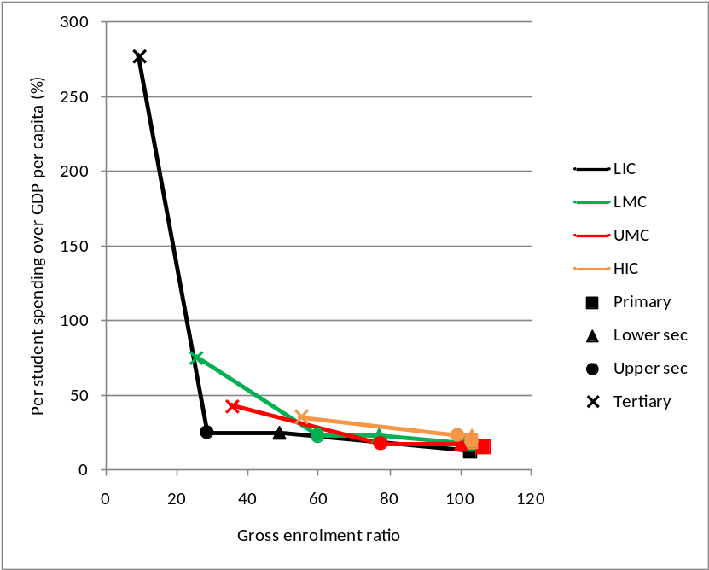
Source: Own calculations from dataset described in section 10.1. Values from 194 countries are used. Mean year across countries is 2007.0.
Figure 38: Magnification of Figure
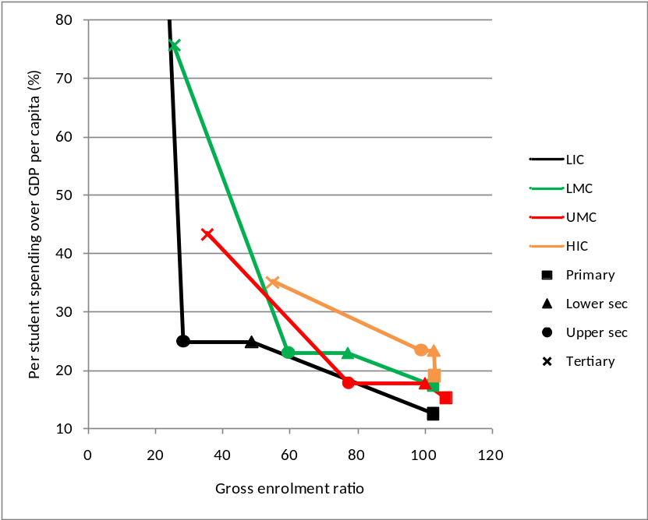

The patterns in the graphs seem unsurprising. On the expenditure side, the especially high level of resourcing devoted to each tertiary student, relative to GDP per capita, in low income countries stands out. This one might expect, given the globally competitive nature of tertiary education (developing country elites often send their young to rich country universities), meaning there is pressure to approximate the per student spending found in high income countries in absolute terms. To a lesser degree, this dynamic would influence the middle income tertiary spending ratios as well. On the enrolment side, if one examines the data points in the graphs against the horizontal axis, it is clear that as countries develop (keeping in mind, however, that these are cross-sectional data), the point at which large numbers of students leave the system shifts from primary schooling, in low income countries, to upper secondary schooling, in high income countries.
How much dispersion is there in the country values around the means behind the points of, say, Figure 38? The coefficients of variation in the next table indicate that there is more dispersion around the spending means than the enrolment means. Moreover, within each of the developing country categories, there is a particularly large degree of variation with respect to the tertiary spending indicator. A graphic illustration of the dispersion with respect to the two dimensions of one of the data points, namely that for upper secondary education in upper middle income countries, is given in Figure 39.
Table 27: Coefficients of variation for enrolment and spending statistics
 | Gross enrolment ratio |  |  |  | Per student spending over GDP/capita
Country category | Primary | Lower sec. | Upper sec. | Tertiary | Primary | Sec. | Tertiary | Countries
LIC | 0.24 | 0.43 | 0.69 | 1.34 | 0.64 | 0.79 | 1.52 | 44
LMC | 0.14 | 0.33 | 0.49 | 0.91 | 0.64 | 0.73 | 1.01 | 52
UMC | 0.08 | 0.14 | 0.23 | 0.54 | 0.37 | 0.43 | 1.29 | 51
HIC | 0.07 | 0.08 | 0.20 | 0.46 | 0.37 | 0.37 | 0.49 | 47
Overall | 0.14 | 0.34 | 0.50 | 0.83 | 0.52 | 0.63 | 2.18 | 194

Figure 39: Figure 38 with dispersion illustrated
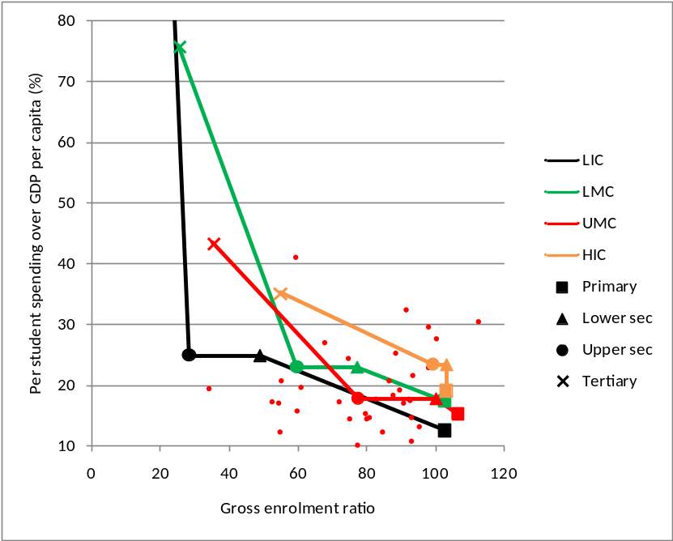
Note: Smaller points illustrate the dispersion of upper secondary values for upper middle income (UMC) countries.

To gain a better sense of the dispersion of country values with respect to the graphs appearing above, a calculation was run where it was determined whether each country-specific two dimensional point was closer to the correct mean point or some other mean point within a specific education level. For instance, if the upper secondary point for Zambia was closer, in a two-dimensional sense, to the lower middle income country mean point than the mean point for one of the other development categories, this Zambia point was given a score of 1 (Zambia is a lower middle income country). If not, it was given a score of zero. The mean across all the scores was 0.51, meaning that half of the time the country-specific points were closest to the mean point of their development category, the other half of the time they were not. What all this indicates is that the dispersion is substantial and that simplistic interpretations of the aggregate multi-country statistics, even where relatively robust patterns are found, should be avoided.
The previous three graphs, which are actually different views of the same graph, illustrate one of two key graph formats that will be used frequently in the analysis that follows. The second graph format is shown below and simply involves joining the points of the previous graphs differently, so that curves represent levels of education, where previously they represented country development categories. In Figure 40 below, we could say that curves point to the trajectory or pathway that, say, tertiary education can be expected to take as a country develops.
Figure 40: Figure 38 viewed transversally
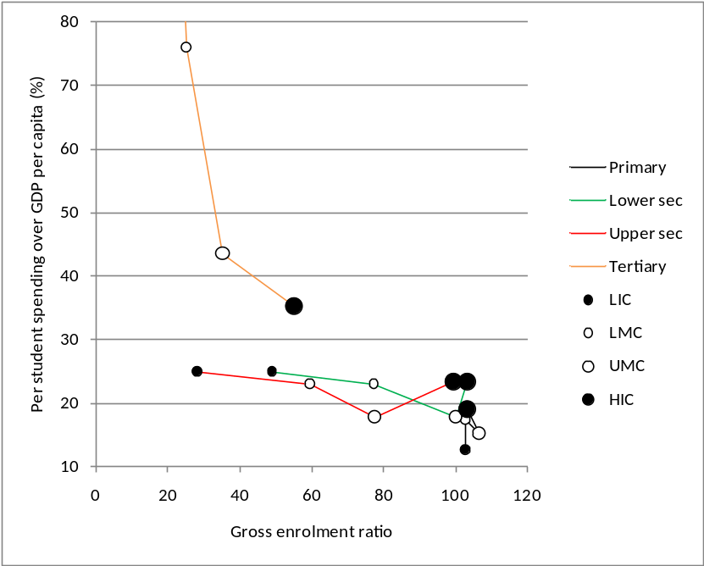
Note: The points referring to development category (LIC etc.) indicate the means along the horizontal and vertical axes for the countries in the category in question.

It seemed worthwhile to explore a variation of the previous graph where more detail on the pathways would be seen, using not just the development categories of countries, but exact per capita income. The result was the following graph, admittedly not a very visually appealing graph, but it serves as a point of departure for a better graph that will be discussed below. Countries were placed in a list in ascending order of income, where this was GDP per capita in 2005 USD PPP terms (using the Penn data source discussed in section 10.1). As above, only data from a recent year not earlier than the year 2000 were used. This list was used to calculate moving averages with respect to the education indicators, where each average covered 21 countries. The lines in Figure 41 are lines joining the averages. Markers have been inserted at points along the pathways corresponding to countries with more or less the median income for a specific development category.
Figure 41: Moving average pathways for enrolment and spending
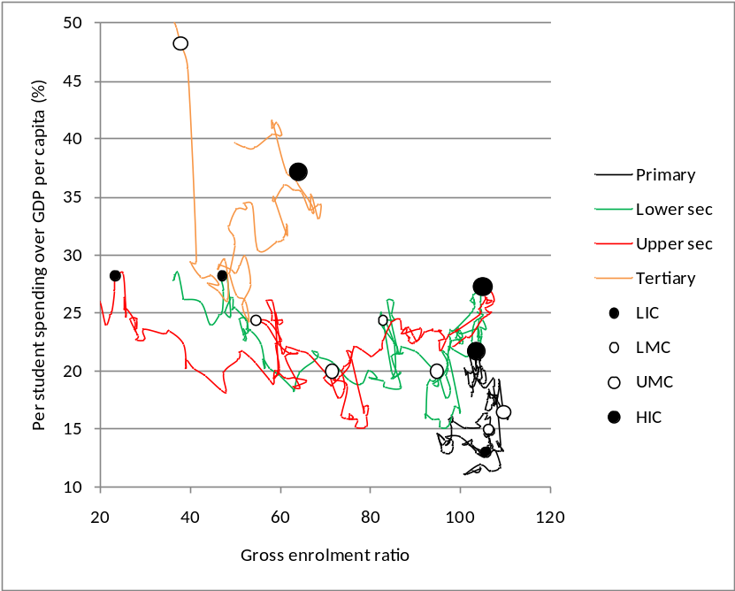
Note: Each marker is situated on a point reflecting the median per capita GDP value for each of the four development categories.

One problem with the foregoing graphs is that they do not consider patterns across all seven indicators within individual countries. Figure 41 does to some extent reflect the relationship across two indicators at a time within individual countries, for instance, primary enrolments and per student spending. A further problem with the last graph is that it assumes that income per capita is a reliable measure of a country’s level of development. One way of dealing with these deficiencies is to completely ignore the income variable and the World Bank’s development category and to seek a development trajectory using just the seven education variables. Factor analysis, using the factor command in Stata, allows us to do this. The ‘principal factor’ option for the command was used, and then using the post-estimation predict command, a single z-score was produced for each of the 112 countries included in the analysis, where this z-score in a sense summarised the seven indicator values. Only 112 countries could be included as each country had to have all seven values. The factor statistical outputs include uniqueness values for each of the seven input variables, which if below around 0.5 point to a high correlation between the variable and the z-score (StataCorp, 2011: 297). As one may expect from the above discussion, the primary GER is not a good predictor of a country’s development status, but nor are the secondary and tertiary spending ratios. The other four variables, however, do display trends moving in the same general direction as the z-score. What is striking is that the z-score displays a high correlation with what would normally be considered a key indicator of country development, namely income per capita. The correlation coefficient if the untransformed income variable is used is 0.67, but it rises to 0.86 if the natural logarithm of income is used. The following graph illustrates the relationship.
Figure 42: Income and a measure of education development
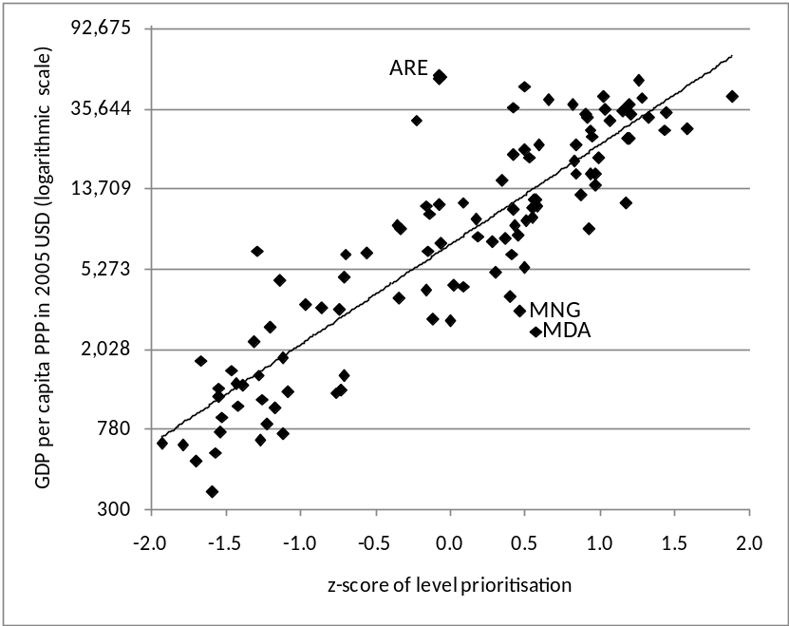
Note: R² for the trendline is 0.74.

Examining the outliers in the graph can be informative for policymakers. If one compares the seven values for United Arab Emirates (ARE) against those of countries with similar levels of income per capita, one finds that this country is an outlier because per student spending is low relative to GDP per capita. This fact, combined with other evidence, might point to spending on specific levels of education being too low. To the right of the trendline, Mongolia (MNG) and Moldova (MDA) are more developed according to their z-scores than their income largely because their level of tertiary enrolment is higher than that of other countries with similar incomes. The governments could use this fact to attract foreign investors, on the basis of their quality of human capital. Of course these kinds of policy conclusions can be drawn without the use of the graph, but the graph represents a novel and compact method of identifying whether countries are possible laggards or pioneers with respect to the global pattern, and with respect to the seven indicators in question.
Figure 41 can now be redrawn with countries ranked in the list according to a more educationally-focussed summary indicator of development, namely the z-score. The result is Figure 43 below. As one would expect, the curves now display fewer random movements because the ‘noise’ previously caused by the use of income as an indicator of development has been removed.
Figure 43: Moving average pathways without use of income
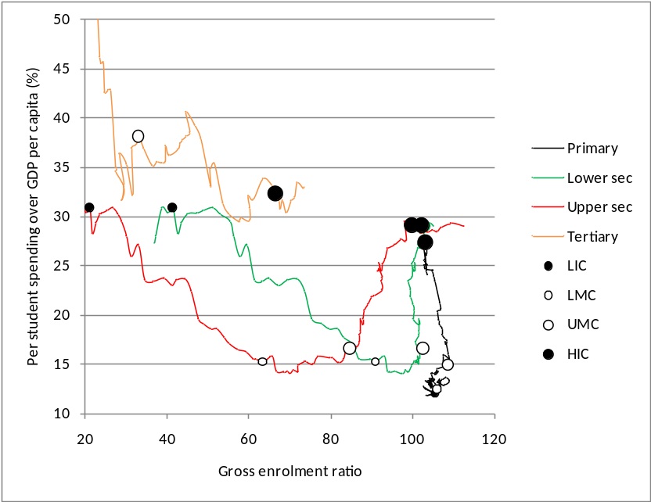
Note: Here, as in Figure 41, curves are smoothed using moving averages that cover 21 countries at a time. The points labelled ‘LIC’ etc. are positioned where they represent the median z-score per development category produced by the factor analysis.

One striking pattern seen above is that at the secondary levels there is a clear decline and then increase in spending per student relative to GDP per capita. Of course it should be kept in mind that this is a cross-sectional view of the data. When historical patterns are examined in the following section, different patterns are seen.
To conclude the analysis of cross-sectional patterns, the next graph takes the per student spending ratios from the previous graph and converts them into absolute monetary terms by multiplying them by GDP per capita. In absolute terms, there is a continuous increase in per student spending as countries develop, but the difference between the spending levels of upper middle income countries and high income countries is stark.
Figure 44: Figure 43 with absolute per student spending
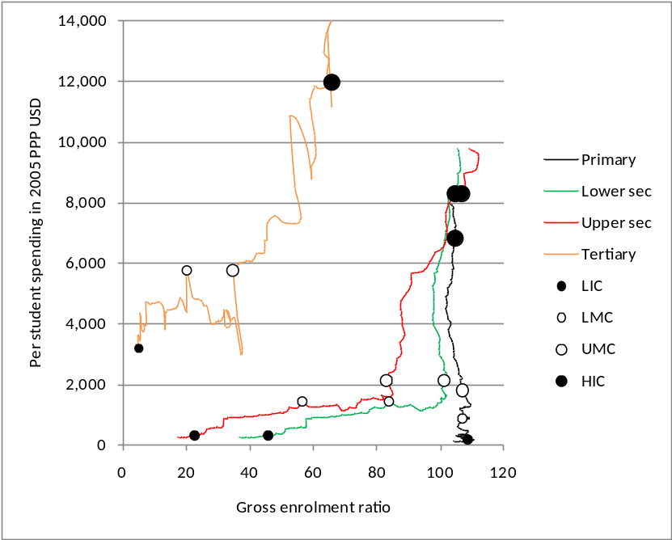

  - Analysis of historical trends
Using cross-sectional data almost as if they revealed historical development trends, as was done in the previous section, is common. This is the approach employed by Mingat and Tan (2003), for instance. Of course historical trends should ideally be examined using historical data, and this is what is attempted in this section. One difficulty posed by a historical analysis is that even inflation-adjusted purchasing power parity per capita income values are not necessarily comparable over longer periods of time. This becomes clear if one examines, for instance, the income thresholds separating low income countries from middle income countries in the 1970s and in the 2000s. As will be seen below, they are very different. But before this complexity is discussed, the breakdown of countries according to development category appearing the World Bank’s World development report for 1978 will be compared to that appearing in the 2012 report to bring to the fore complexities around inconsistent classifications, and inconsistent sets of countries (World Bank, 1978: 76; World Bank, 2011b).
The 1978 report of the World Bank used as its main categories ‘industrialised countries’, ‘middle income countries’ and ‘low income countries’, but these excluded 25 countries classified as ‘centrally planned economies’ and three classified as ‘capital surplus oil exporters’. The following table shows the degree to which countries moved between the three main 1978 categories and the 2012 categories, where for the latter lower and upper middle income countries have been collapsed into one category, middle income country. The seven countries which moved from the middle income status in 1978 to the low income status in 2012 were six Sub-Saharan Africa countries plus Nicaragua. The five that moved in the opposite direction, from low to middle income status, were all South Asian or Southeast Asian countries. The one country that moved from industrialised country to middle income country status was South Africa, but an examination of income values reveals that in 1978 South Africa’s per capita income was well below that of any other industrialised country, suggesting that anomalous criteria were used when South Africa was classified. All other industrialised countries in 1978 can clearly be considered high income countries too. Finally, the ten countries that moved from the middle to high income status included five Southern European countries, four East Asian countries and Israel.
Table 28: 1978-2012 country classification changes I
2012 ➔  1978 ⬇ | LIC | MIC | HIC | Totals 1978
LIC | 28 | 5 |  | 33
MIC | 7 | 44 | 10 | 61
IC |  | 1 | 18 | 19
Totals 2012 | 35 | 50 | 28 | 113
Note: In this and the following table, ‘IC’ refers to ‘industrialised countries’.

For the historical analysis it seemed important to impute, where possible, 1970s country development categories according to the three main income groups, where such categorisations had not been made for 1978. The first step was to take the 1978 categories of countries that ceased to exist, in particular the Soviet Union, and to assign the same categories to the ‘splinter country’, for instance Ukraine. The next step was to identify income levels that could be used to separate low from middle, and middle from high income, in 1970, the earliest year for which the education data were available, but also 2009, the last year for which the Penn income data were available, using the 1978 and 2012 categories respectively. It was thus assumed, for instance, that categories would not have changed between 1970 and 1978. The Penn income values from 1970 and 2009 were taken and points found at which the least number of countries would find themselves on the wrong side of the divide. For instance, in establishing an income value to divide low income countries from middle income countries in the 1970 data, a value was found that minimised the number of low income countries with an income above that level plus the number of middle income countries with an income below that level. It was found that the income level dividing low from middle income countries was 1,200 USD in 1970 and 2,300 USD in 2009. This is despite the fact that income values were real inflation-adjusted PPP values, which might create the impression that thresholds between country development categories should remain static over time. That this should not be the case is unsurprising if one considers the great conceptual and technical difficulties that exist in making prices comparable over time and space. This was discussed in Part I of the dissertation.
The division between the middle and high income categories was found to be 10,000 USD for 1970 and 24,000 USD for 2009. Here industrialised country was considered as synonymous with high income country, but South Africa was considered a middle income country in the 1970s. The 1970 income thresholds were used to place the 7 ‘centrally planned economies’, or their splinter countries, which had Penn income data for 1970, into one of the three income categories. Then the remaining centrally planned economies and ‘capital surplus oil exporters’ were categorised using the earliest available income value (the mean year was 1991) and the 2009 income threshold values. This method was not ideal, but the resultant 1970s classifications seemed appropriate. Finally, 43 countries, mainly from Africa, which did not appear in the World Bank’s 1978 list but which did have 1970 Penn income values were categorised, using the 1970 income thresholds. The result, shown in Table 29 below, was 184 countries which had categories for both 1978 and 2012.
Table 29: 1978-2012 country classification changes II
2012 ➔  1978 ⬇ | LIC | MIC | HIC | Totals 1978
LIC | 34 | 13 |  | 47
MIC | 9 | 86 | 14 | 109
IC |  | 2 | 26 | 28
Totals 2012 | 43 | 101 | 40 | 184

The left-hand graph below is a reproduction of Figure 37. The right-hand graph represents the comparable situation using the oldest UIS data available and the country categorisations for the 1970s, derived as explained above. Along the lines of the approach used for the 2007 graph, for the right-hand graph a score of data availability per country and per year was calculated and the earliest year with the maximum score, as long as the year was before 1980, was used for each country. The mean year used across countries was 1973.0. The 1973 graph reflects 168 countries, against 194 for 2007. If one were to use the assumption, clearly a problematic one, that income values from 1970 are comparable to those of 2009, and that one can thus use the same thresholds between income categories in 1973 as one does in 2007, the resultant 1973 would look different, but it would still be closer to the right-hand graph below than the left-hand graph. The conclusion we can thus draw is that however one views the data, there have been large shifts in recent decades in the way similarly developed countries prioritise education levels.
Figure 45: Education levels in 2007 and 1973
±2007 | ±1973
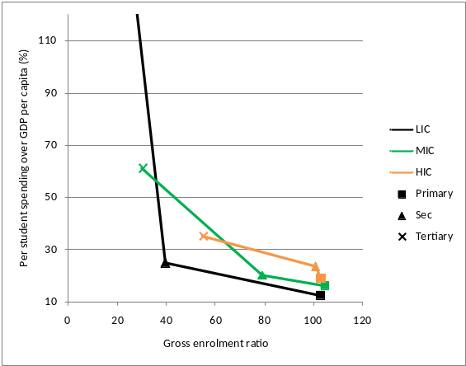 | 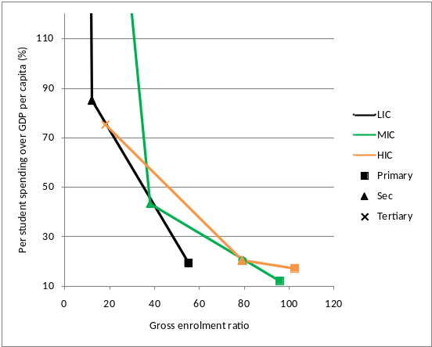

The following table presents the values behind the above graphs. The general trend is that the enrolment values have risen and that expenditure values have dropped. On the enrolment side the move towards universal primary schooling is not surprising, given the prevailing policy pressures, but that secondary and tertiary GERs should have increased to the extent they have is remarkable. For instance, enrolment at the tertiary level more than tripled in all three development categories. Enrolments at the secondary level in low and middle income countries more than doubled. As seen in the last three rows of the table, the reductions in the spending indicator values are proportionally strikingly similar to the increases in the GERs, suggesting that there has been a trade-off between high spending and higher enrolments. If one ignores changes in the distribution of the population over ages, the closer the ratios in the bottom left panel of the table are to the corresponding ones in the bottom right panel, the stronger the likelihood that the overall level of investment in education relative to GDP remained the same, and that similar proportions of GDP were simply spread out over more students. As will be discussed in the conclusion in section 11, historical trends of the kind displayed here have received considerable attention in the economic literature, yet how optimal they have been remains an unresolved matter.
Table 30: Education levels in 2007 and 1973
 | Gross enrolment ratio |  |  | Per student exp. / GDP per capita
 | Primary | Sec. | Tertiary | Primary | Sec. | Tertiary
2007
LIC | 103.0 | 39.5 | 9.2 | 12.5 | 24.8 | 276.9
MIC | 104.5 | 79.1 | 30.1 | 16.2 | 20.1 | 61.1
HIC | 103.0 | 100.6 | 54.8 | 19.0 | 23.5 | 35.3
1973
LIC | 55.2 | 12.0 | 1.4 | 19.3 | 85.0 | 1314.3
MIC | 95.8 | 38.0 | 8.1 | 12.1 | 43.4 | 322.1
HIC | 102.5 | 79.0 | 17.7 | 17.3 | 20.4 | 75.6
Change | 2007 over 1973 |  |  | 1973 over 2007
LIC | 1.9 | 3.3 | 6.8 | 1.5 | 3.4 | 4.7
MIC | 1.1 | 2.1 | 3.7 | 0.7 | 2.2 | 5.3
HIC | 1.0 | 1.3 | 3.1 | 0.9 | 0.9 | 2.1

One complication if one wants to analyse the income and education indicator data described in section 10.1 as a panel dataset is that the meaning of the income values change over time, as mentioned previously. The same supposedly real income value can mean a middle income in 1970, but a low income in 2009, for example. The complication is not insignificant if one considers that the shifting thresholds referred to above imply roughly a halving the value of the supposedly constant USD over four decades, if one assumes that, for instance, the difference between a low income country and a middle income country means in the 2000s what it did in the 1970s. An attempt was made to use the income thresholds separating the development categories discussed earlier to adjust the Penn income data so that, say, 10,000 USD would mean the same thing in 1970 and 2009, in terms of the its location within the country development categories. However, this attempt was abandoned as the adjusted values obtained introduced counter-intuitive results, in particular negative GDP per capita growth for many countries and many years where the original values reflected positive growth.
A more serious and fundamental complication if one wants analyse the historical patterns in a manner that goes beyond a simply descriptive approach, as seen in Table 30, is that the historical period reflected in the data is too short to provide a robust picture of what typically occurs to the education indicators of a country over a longer development trajectory. This is not just a data problem. Country development as one might understand it in development economics has not been occurring long enough for very neat patterns to be extractable from the historical data. It is of course debatable whether changing technologies and the more recent phenomenon of a changing ecology would ever allow neat and consistent patterns of country development to emerge. This is why development economics has so often turned to cross-sectional analysis in attempting to identify the development trajectories that appear to prevail at a specific historical point. Yet the short historical series we have in the data present some opportunities, in particular the opportunity to examine whether the cross-sectional patterns are replicated in the longitudinal patterns.
In the data we have, the cross-sectional patterns would tend to dominate over the historical patterns if, for instance, one simply regressed the secondary GER on income. The coefficient on income would describe differences across countries to a much larger degree than differences within countries across years. The intraclass correlation coefficient if one takes all the historical values and treats country as one’s class is high, for instance 0.817 for the secondary GER and 0.621 for the tertiary GER. Thus 82% of the variation of one’s secondary GER values is explained by the country, as opposed to the year. The econometrics answer to the need to separate cross-sectional from historical trends is a fixed effects model. The fixed effects model represented by equation (88) below was used. W is the indicator value for country i and year t. Apart from the overall intercept λ₀, each of the n countries except for one also has an intercept S. Thereafter there are three slope coefficients β linked to the natural logarithm of income per capita I, growth g in I between t and t minus 1, and the interaction between I and g. The results are presented in Table 31. For each of the 11 indicators, one of four variants of equation (88) was used. Both the untransformed version of the dependent variable and its natural logarithm were tested. Models were moreover run with and without the interaction term. The model with the interaction term was rejected if this term’s coefficient was not significant at the 10% level. Thereafter the model with the highest R² value was used. One thing that should be noted about the results is that annual growth in income displays a statistically significant and independent association with all the indicator values. This points to different trajectories for the indicator values for faster and slower growing economies. The shape and magnitude of this association will be explored further in the next section.
(88)
Table 31: Regression of indicator values on historical income
 |  |  | Coefficient on...
Variable | Obser-vations | Cons-tant | Nat. log of income | Growth | Interaction of prev. two | R²
GER primary (ln) | 5562 | 3.9 | 0.1*** | 1.4*** | -0.2*** | 0.02
GER lower secondary (ln) | 1780 | 1.0 | 0.4*** | 1.3*** | -0.2*** | 0.19
GER upper secondary (ln) | 1697 | 0.2 | 0.4*** | 1.5*** | -0.2*** | 0.15
GER secondary | 4832 | -178.1 | 28.1*** | 37.8** | -7.2*** | 0.34
GER tertiary (ln) | 4008 | -9.3 | 1.4*** | 2.5*** | -0.4*** | 0.40
Vocational ISCED 2/3 | 4193 | 27.2 | -1.4*** | -2.6* |  | 0.01
Post-secondary non-tert. (ln) | 750 | 12.4 | -1.2*** | 1.2*** |  | 0.13
Tertiary engineering | 733 | 61.8 | -5.2*** | -3.4* |  | 0.10
Per student exp. primary (ln) | 2087 | 0.7 | 0.2*** | -0.3** |  | 0.04
Per student exp. sec. | 2021 | 66.7 | -4.4*** | 89.1* | -10.2* | 0.01
Per student exp. tertiary (ln) | 2013 | 12.4 | -0.9*** | -0.6*** |  | 0.24
Note: ‘(ln)’ refers to the fact that the dependent variable was expressed as a natural logarithm. The per student expenditure values expressed as a ratio to GDP per capita. Regression results are from a model with fixed effects for countries. *** indicates that the estimate is significant at the 1% level of significance, ** at the 5% level, and * at the 10% level. Growth in the model was expressed as a fraction, e.g. 0.03. R² values refer to within-country explanatory power. The overall R² would be higher.

The following two graphs illustrate the average annual gains or losses for the indicators dealing with the three key education levels, at different income levels, using the slope coefficients from the previous table. An annual growth in income per capita of 2.5% was assumed. The patterns seen in the graphs are broadly in agreement with the cross-sectional findings discussed in section 10.3 in the sense that secondary and tertiary enrolment GERs increase with development and that the spending ratios decrease. One anomaly, however, is that the conclusion one may draw from the cross-sectional picture (Figure 43, for instance) that the primary and secondary spending ratios increase at high levels of development, is not supported by the historical trends in the graphs appearing below, and nor is it suggested by the non-parametric analysis presented below. Moreover, the large relative magnitudes of the secondary enrolment and spending shifts seen below are not supported by the cross-sectional picture. For instance, if one uses just the 2007 values in Table 30 and assumes an annual growth in income of 2.5%, between the LIC and LMC medians one might expect the annual increase in the secondary GER to be 0.8, against the 2.0 suggested by the historical trend in Figure 46.
Figure 46: Historical trends for education indicator (parametric)
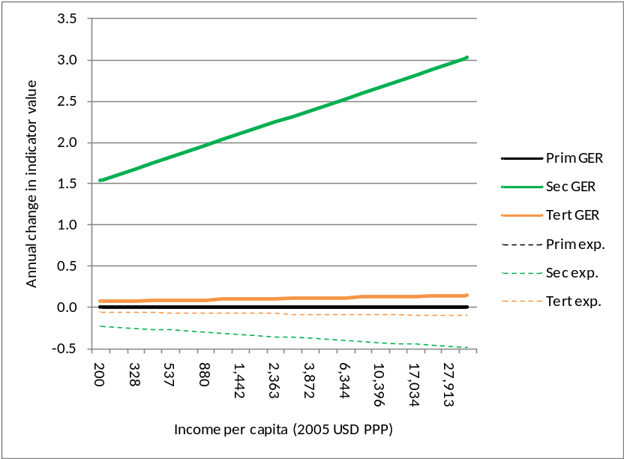
Note: Income values on the horizontal axis are expressed on an exponential scale based on a 2.5% annual growth rate.

Figure 47: Magnification of Figure 46
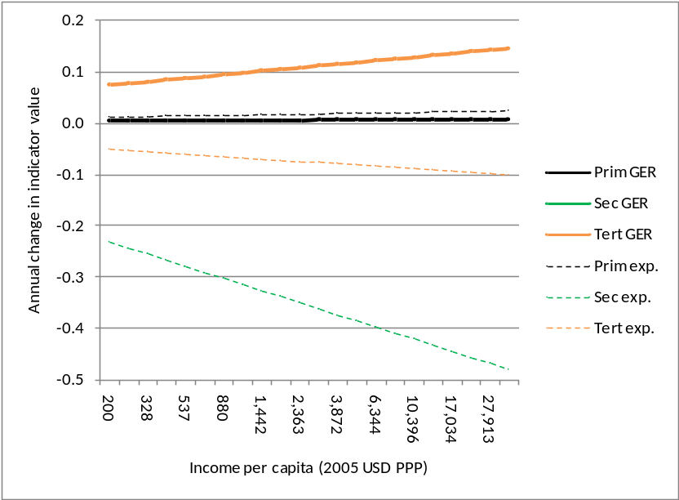

The ‘Vocational ISCED 2/3’ indicator, for which we have values covering four decades (Table 25), comes with a negative coefficient on income in Table 31. However, this indicator refers to the percentage of secondary level enrolments in vocational streams. If one multiplies it by the secondary GER and then re-runs the model, the coefficient on income is positive. Vocational enrolments at the secondary level thus tend to increase relative to population as a country develops, but not as fast as non-vocational secondary enrolments. To illustrate the general trend, across all countries the mean percentage of secondary enrolments which are vocational dropped from 16% to 14% between the 1970s and the 2000s, but secondary vocational enrolments relative to the population increased from 6% to 12% over the same period.
A similar pattern is seen for the post-secondary non-tertiary and tertiary engineering indicators, for which data are available only since 1998. For the former, the shift between the 1998 and 2012 was from 15% to 13%, whilst as a percentage of the population enrolments moved from 3.5% to 4.0%. Tertiary engineering enrolments as a percentage of the age-relevant population moved from 5.7% to 6.5% over the same period.
One limitation of the fixed effects models discussed above is that the coefficients on income can be said to capture both a time invariant income correlation and the historical effect discussed earlier whereby, for instance, large increases in tertiary enrolments occurred in developed countries beyond what seems attributable to income. The models reflected in Table 31 were rerun with three decade dummy variables inserted: whether a year was 1980 or later, 1990 or later, or 2000 or later. These dummies might provide an indication of the magnitude and timing of historical effects. Obviously the correlation between the dummy variables and income within each country would be high and thus multicollinearity in the explanatory variables would be high. This should caution one against reading too much into a comparison between the coefficients on the income variable and those on the dummies seen in Table 32. Yet it seems noteworthy that in general the coefficients in all columns are simultaneously significant, across all indicators. What is perhaps most telling about the results is when the large historical trends occurred. Primary enrolments received a boost, beyond what income levels would predict, in the 1980s, and again after 2000. For secondary enrolments, both the 1980s and 1990s saw large upward movements. Tertiary enrolments increased above all in the 1990s. In general, the downward trends in the expenditure ratios occurred when the upward trends in the GERs occurred, making it plausible that enrolments could expand partly because trends in spending per student were contained, or did not increase as fast as GDP per capita.
Table 32: Regression of indicator values on income and decades
 | Coefficient on...
Variable | Nat. log of income | Growth | Interaction of prev. two | Dummy for since 1980 | Dummy for since 1990 | Dummy for since 2000 | R²
GER primary (ln) | -0.1*** | 69.7*** | -7.4*** | 7.3*** | 1.4*** | 6.9*** | 0.164
GER lower secondary (ln) | 17.0*** | 29.4 | -4.2* |  |  | 4.0*** | 0.213
GER upper secondary (ln) | 10.6*** | 1.9 | -0.2 |  |  | 0.1*** | 0.178
GER secondary | 11.9*** | 11.9** | -2.9* | 8.8*** | 8.3*** | 0.2*** | 0.586
GER tertiary (ln) | 13.0*** | -7.5 | -0.2 | 3.0*** | 5.5*** | 0.4*** | 0.680
Vocational ISCED 2/3 | 0.2*** | 16.9* | -2.5** | -0.1*** | -1.0*** | -0.2*** | 0.043
Post-secondary non-tert. (ln) | -1.1*** | 70.9*** | -6.7** |  |  | -0.1 | 0.128
Tertiary engineering | -0.2*** | -9.5 | 0.7 |  |  | 0.0 | 0.105
Per student exp. primary (ln) | 1.9*** | 21.8 | -3.3** | -0.1 | 0.1 | 0.1*** | 0.045
Per student exp. sec. | 0.2*** | 114.3 | -14.3*** | -10.6*** | -3.7* | 0.0 | 0.087
Per student exp. tertiary (ln) | -0.3*** | 941.5 | -127.9 | -0.3*** | -84.7*** | -0.2*** | 0.361
Note: ‘(ln)’ refers to the fact that the dependent variable was expressed as a natural logarithm. The per student expenditure values expressed as a ratio to GDP per capita. Regression results are from a model with fixed effects for countries. *** indicates that the estimate is significant at the 1% level of significance, ** at the 5% level, and * at the 10% level. Growth in the model was expressed as a fraction, e.g. 0.03. R² values refer to within-country explanatory power. The overall R² would be higher.

What might be more useful for policymakers than the parametric patterns described above would be a non-parametric, or semi-parametric, graphing of the indicator trends over time, relative to income, to reflect irregular variation. A convenient tool for this are curves with lowess smoothing. The next two graphs use such curves, with the ‘bandwidth’ set at the Stata default of 0.8, meaning that the locally weighted regression analysis run for each point on the curve uses 80% of all observations, with more distant observations, with respect to the x-axis, being weighted much less. The x values are the Penn USD income values at 2005 PPP prices. The y values were obtained by running multiple regressions in the dataset. In each regression, data from just five consecutive years within one country were used, with the indicator values being regressed on year to obtain the slope. The resultant coefficient on year would then be attached to the last year. So, for instance, the 2006 secondary GER slope for South Africa would be the slope of the indicator values on year for 2002 to 2006.
Figure 48: Lowess curves for historical indicator trends against income
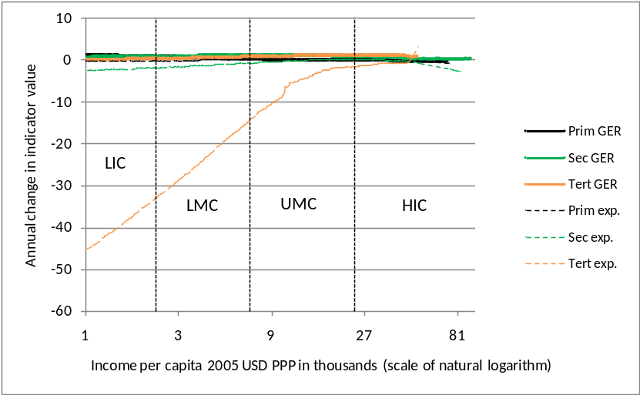

Figure 49: Magnification of Figure 48
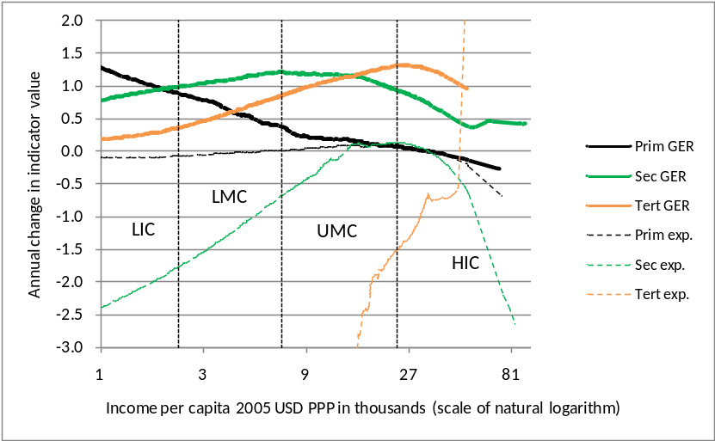

The pattern seen earlier of decreasing secondary and tertiary expenditure ratios as income rises appears again, except here these decreases are reduced over time whilst in Figure 47 they appeared to become larger over time. Moreover, decreases in the primary GER as income increases, presumably as inefficiencies in the form of high grade repetition are resolved, become clear in the above graph, whilst this did not emerge from the parametric analysis.
If we redo the last two graphs using only the y values for 2000 and later, in order to provide a picture of what can be considered current trends, we obtain the following two graphs. Using only the recent data results in larger secondary and tertiary GER increases and smaller reductions in the expenditure ratios for these education levels.
Figure 50: Lowess curves for just 2000 and beyond
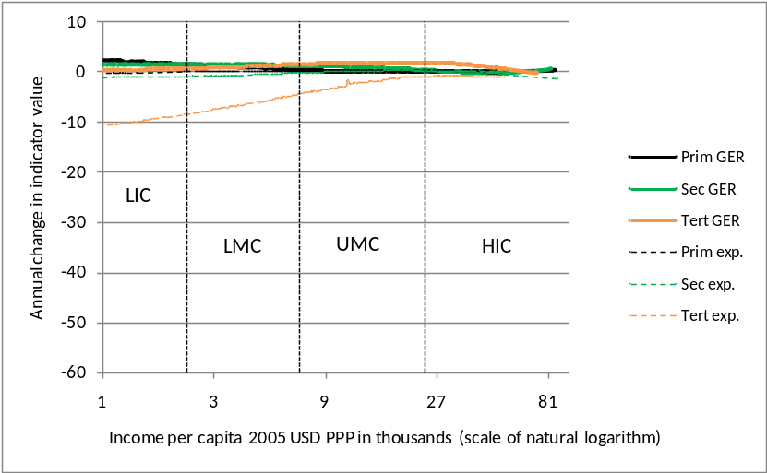

Figure 51: Magnification of Figure 50
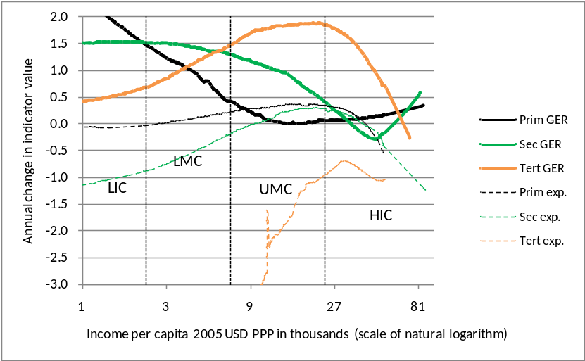

What has been presented above is important in terms of uncovering basic patterns in the data. A more policy-oriented discussion using the graphing methods developed here appears in the next section. One region-specific policy matter concludes this section, namely the question of whether the past prioritisation of primary schooling by international agencies in the case of Sub-Saharan Africa (SSA) led to the under-prioritisation of the secondary and tertiary levels. Some examination of the GER values suggests that one’s answer to this policy question could be yes or no, depending on how one interprets the data. The following two graphs use GER values for countries that are not high income countries. Figure 52 uses all the values available, whilst Figure 53 uses the values of just those countries where at least 80% of the values were non-missing. The similarity of the two graphs is remarkable if one considers that only a quarter of the number of SSA countries is used for the second graph compared to the first graph. The graphs use data from up to around four Sub-Saharan African upper middle income countries, and around half of the countries from the other regions are upper middle income countries. However, this fact does not influence the overall picture. If upper middle income countries are excluded from the graphs, leaving just low and lower middle income countries, the picture remains virtually unchanged.
Figure 52: Sub-Saharan Africa’s prioritisation of education levels I
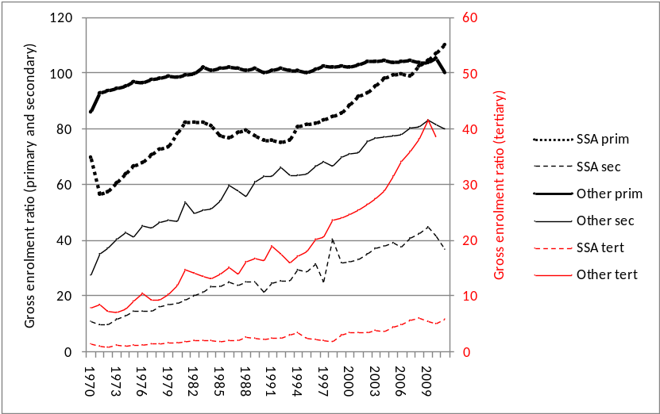
Note: The average number of countries per yearly data point for SSA is 38, 30 and 21 for the primary, secondary and tertiary levels. The figures for non-SSA are 72, 64 and 54.

Figure 53: Sub-Saharan Africa’s prioritisation of education levels II
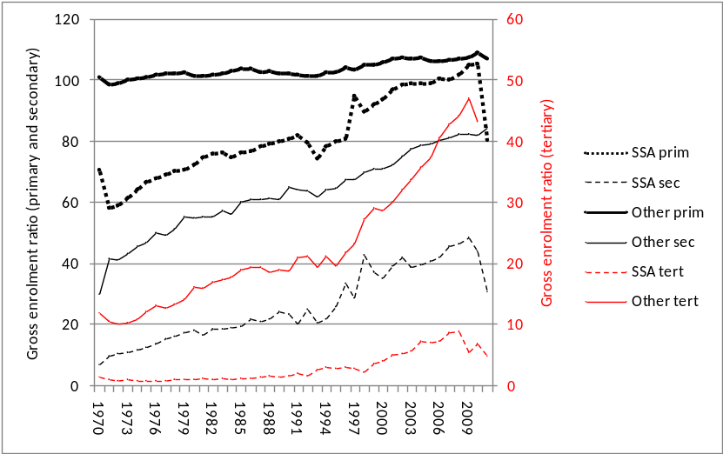
Note: The average number of countries per yearly data point for SSA is 8, 7 and 6 for the primary, secondary and tertiary levels. The figures for non-SSA are 25, 24 and 23.

In defence of the actual historical trend, one could argue that the SSA region succeeded in bringing its primary GER up to the level of other developing regions over the four decades, whilst tertiary enrolments also increased substantially, albeit off a low base. Specifically, tertiary GER values increased by a factor of 6.5 over the four decades in the region against 4.5 for other countries (ratios taken from the second graph). Similarly, the increase in secondary enrolments was steeper in SSA than elsewhere. The ratio of the primary GER to the secondary GER declined from 59 to 14, whilst the ratio of the secondary GER to the tertiary GER declined from 6 to 2. These ratios shifted to a greater degree in the region than elsewhere. The proportion of SSA students enrolled at the primary level, as opposed to some other level, was thus far greater in 1970 than in 2011. But one could also use the data to support the opposite argument. By 2011, whilst the SSA region was no longer behind with respect to primary enrolments, its secondary enrolments were at around half of the level found in comparator countries, whilst it lagged even further behind with respect to tertiary enrolments. One may ask whether the priority should not rather have been to close the gaps in a manner that focussed less on universal primary schooling, and more on balancing enrolments across levels, using international patterns as a norm, and thus for instance accepting that universal primary schooling would not be reached whilst secondary enrolment levels were still so low. The last two years in the first graph, 2010 and 2011, display a situation where the primary GER in SSA was slightly higher than that elsewhere. If this trend continues, the argument that the region has over-prioritised primary schooling could be strengthened.
  - Growth and education prioritisation patterns
Sections 10.3 and 10.4 have explored ways of viewing and analysing the UIS data in combination with the Penn income data. They also served as an important check of anomalies in the data, for instance the changing meaning of the real income values over time. On the whole it was found that the UIS data, despite gaps, are sufficiently complete and correct to produce meaningful patterns that could be of interest to policymakers. Below, how the patterns seen in the UIS data differ by level of economic performance is examined. The implications for policymakers are also discussed. Economic performance is mostly defined in terms of increases in the Penn income per capita values. However, where indicators are inserted into the semi-Bayesian model of Sala-i-Martin, Doppelhofer and Miller (2004), performance is gauged in terms of overall GDP growth.
The following graph follows the format of Figure 38, but provides separate curves for the top and bottom terciles of performers. Performance per country is the average annual percentage increase in income per capita, found by regressing the natural logarithm of the Penn income values on year. The top and bottom terciles were identified within each of the four development categories applicable in 2012. The data behind the next graph are presented in Table 33. The table is perhaps most convenient for interpreting the trends. The last four rows of this table show the difference with respect to the indicator values between the faster and slower growing countries after income has been controlled for. Specifically, within each development category, and with each observation being one country, the indicator value was regressed on the natural logarithm of 2007 income and two dummies, one indicating that the country was a fast grower, the second that the country was a slow grower. Each difference value at the end of the table is the coefficient on the fast growth dummy minus the coefficient on the slow growth dummy.
Figure 54: Educational level prioritisation ±2007 by growth category
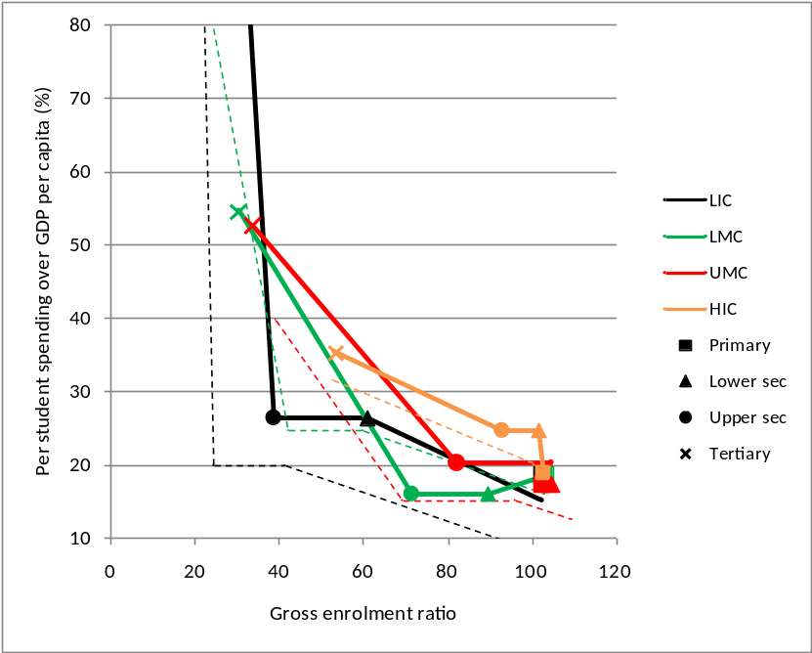
Note: This graph is a modification of Figure 38. Solid lines represent better performing counties, whilst dotted lines represent worse performing countries.

Table 33: Indicator values ±2007 by growth category
 | Gross enrolment ratio |  |  |  | Per student spending over GDP/capita
Country category | Primary | Lower sec. | Upper sec. | Tertiary | Primary | Sec. | Tertiary | Countries
Within top tercile with respect to 1970-2009 growth
LIC | 103 | 61 | 39 | 15 | 15 | 26 | 254 | 14
LMC | 103 | 90 | 72 | 30 | 19 | 16 | 55 | 18
UMC | 103 | 105 | 82 | 34 | 17 | 20 | 53 | 18
HIC | 103 | 102 | 93 | 53 | 19 | 25 | 35 | 15
Within bottom tercile with respect to 1970-2009 growth
LIC | 95 | 41 | 24 | 6 | 9 | 20 | 534 | 13
LMC | 103 | 60 | 42 | 12 | 16 | 25 | 117 | 16
UMC | 110 | 96 | 69 | 39 | 13 | 15 | 40 | 16
HIC | 103 | 100 | 100 | 53 | 16 | 20 | 32 | 14
Difference between top and bottom terciles (positive means value in best tercile is higher)
LIC | 7 | 20 | 14 | 9 | 6 | 6 | -280
LMC | 0 | 30 | 30 | 18 | 2 | -8 | -62
UMC | -7 | 9 | 13 | -5 | 5 | 5 | 13
HIC | -1 | 2 | -7 | 0 | 3 | 4 | 4
Difference between top and bottom terciles after controlling for income
LIC | 9 | 11 | 7 | 2 | 10 | 14 | -189
LMC | -4 | 18 | 15 | 4 | -3 | -8 | -24
UMC | -6 | 8 | 9 | -7 | 3 | 3 | 16
HIC | -1 | 2 | -7 | -2 | 3 | 5 | 7

The general patterns hold whether one controls for income or not, though differences are, as one might expect, reduced when the income control is introduced. What are these general patterns? Better performing countries tend to have tertiary education indicator values, on both the enrolment and spending sides. These countries thus prioritise education more. The pattern becomes more pronounced the lower the development category. There is one notable exception. Amongst lower income countries, those that grow slowly tend to have a higher tertiary education spending ratio. The fact that the general pattern of higher spending ratios, at all education levels, in faster growing economies should apply in high income countries, seems noteworthy. Work such as that by Krueger and Lindahl (2001) suggests that high income countries stand to gain little from investing more in education. Of course the statistics in Table 33 say nothing conclusive about cause and effect. But one plausible interpretation is that well-governed countries, in terms of growth, are also better at managing their education systems, and understand that certain spending thresholds must be met if the education system is to support development optimally.
The fact that low and lower middle income countries that grow slowly display higher spending ratios for tertiary education warrants some closer scrutiny. One hypothesis would be that these countries are smaller countries where costs are inflated because economies of scale cannot be attained. The following correlation matrix, which ensures that for every pair of variables all observations with non-missing values in the pair are included, provides some initial answers. As already seen, lower growth is associated with higher spending ratios at the tertiary level. Moreover, lower growth is indeed associated with smaller populations and population is negatively correlated with the tertiary spending ratio. But correlations are extremely low. Moreover, smaller countries also have higher primary and secondary spending ratios and here one would not expect an economy of scale problem.
Table 34: Correlation matrix for LIC and LMC education spending
 | Natural log of income | Average annual growth | Population | Primary spending | Secondary spending | Tertiary spending
Natural log of income | 1.00
Average annual growth | 0.58 | 1.00
Population | 0.04 | 0.11 | 1.00
Primary spending | 0.34 | 0.14 | -0.10 | 1.00
Secondary spending | -0.10 | -0.04 | -0.10 | 0.26 | 1.00
Tertiary spending | -0.33 | -0.23 | -0.08 | -0.06 | 0.29 | 1.00
Note: Education indicator and income values used were those of around 2007. Growth is for the period 1970-2009.
Source: As for previous tables, but with population being 2010 estimates drawn from the online data-querying facility for the 2008 World Population Prospects of the UNSD.

What is revealing is to examine the regional dynamics behind the high tertiary spending phenomenon. The natural logarithm of USD tertiary spending per student, where the USD value was found by multiplying the tertiary spending ratio by GDP per capita, was regressed on the natural log of income, total population and dummies for world regions used by the World Bank. Only countries with an income value of 7,000 or below was included in the model. The coefficient on population was found to be insignificant. However, the coefficient on the Sub-Saharan Africa (SSA) dummy was positive and significant, regardless of the excluded dummy, whilst Eastern Europe, Latin America and East Asia and Pacific emerged as having low tertiary spending values. Even if all the regional dummies were excluded, population was still not a statistically significant predictor. The phenomenon of high tertiary unit costs amongst poorer nations seen in the data seems to be driven largely by what happens in the SSA region. This can be seen in Figure 55 below. The patterns point to a need within many SSA countries to restructure the way tertiary education is offered. There could be an artificial economy of scale problem in these countries in the sense that enrolments at the tertiary level have been low, partly for structural reasons which include low secondary enrolments (see Figure 52), which in turn could have contributed towards uneconomically small universities.
Figure 55: The SSA region and spending on tertiary education
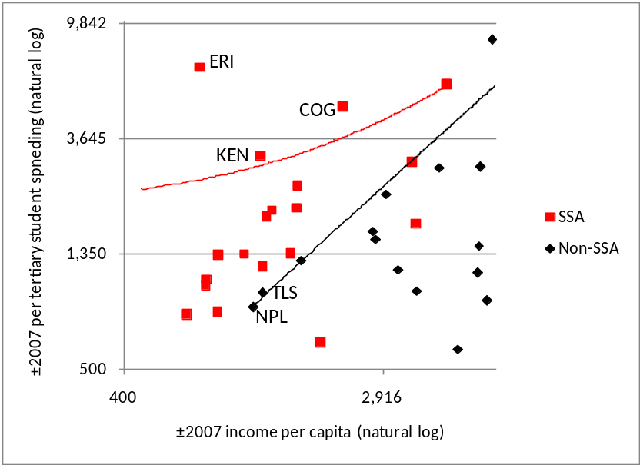
Note: Trendlines are only for countries with less than a per capita income of USD 7,000 in 2005 PPP terms in ±2007. The graph magnifies the bottom left part of the graph and does not display all pairs of data points. Country codes are ISO codes – see Appendix A of Part I of the dissertation for explanations.

The graphs reflecting historical trends in the data discussed in the previous section were reproduced for better and worse economic performers (using the performance criteria explained earlier). The following graphs (which are comparable to Figure 48 and Figure 49 above) are interesting mostly with respect to secondary and tertiary spending trends. At the low and lower middle income levels, it is the faster growing economies that have seen the largest annual reductions in their tertiary spending ratios. This would agree with the pattern seen earlier of on average lower tertiary spending ratios for less developed countries in the 2000s that had grown faster. The secondary spending ratio, in contrast, has declined faster in economies that grew more slowly, at least at the low and lower middle income levels. Table 33 revealed a mixed picture for the 2000s, with low income countries displaying a positive correlation between growth and the secondary spending ratio, whilst the correlation in lower middle income countries was negative.
Figure 56: Lowess curves for historical trends by economic performance
Highest tercile of performers | Lowest tercile of performers
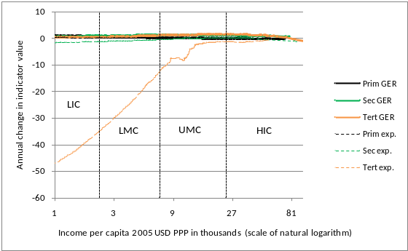 | 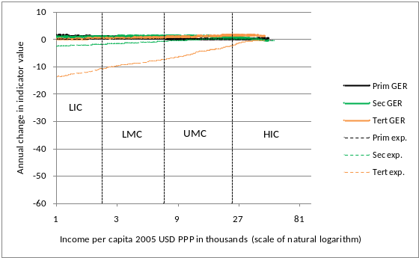
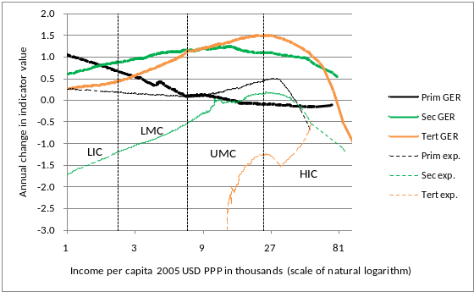 | 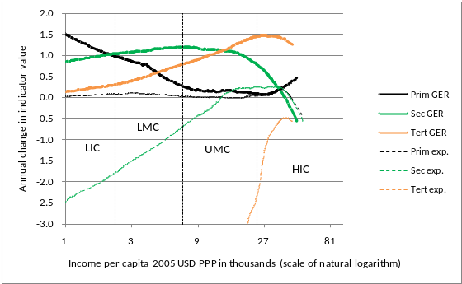

A rather good way of testing the conditional correlation between the education indicators discussed in the previous sections and economic growth is to insert these indicators into the Bayesian averaging of classical estimates (BACE) model of Sala-i-Martin, Doppelhofer and Miller (2004), henceforth referred to as SDM. This technique was discussed in detail in Part I of the dissertation. If early values for the indicators are prioritised by the model, this could have policy implications and provide guidance for the kinds of explanatory variables to select in cross-country growth regressions.
In proceeding with the BACE analysis, it was necessary to consider the trade-offs between keeping education variables and keeping countries in the dataset to be used, given that the model cannot handle missing values. Moreover, various permutations of the indicator values were tested. In the end, after some preliminary testing of various education variables in the BACE process, it was decided to insert five variables into the original SDM model: the average annual change in the secondary and tertiary spending ratios (over the four decades), and the natural logarithm of the absolute USD value of per student spending in the 1970s for the primary, secondary and tertiary levels. The last three variables were obtained by multiplying the UIS spending ratio by GDP per capita, and the mean across the earliest three values from the 1970s was used. Enrolment ratios did generally not perform well in the SDM model, and clearly not as well as the derived spending variables. The 1970s primary GER did perform relatively well, but not as well as the 1960 primary GER used in the original SDM work.
Results for explanatory variables displaying high probabilities of being included in an optimal model, according to the BACE methodology, are displayed in Table 35 below.
Table 35: BACE regression outputs – growth on UIS and other data
 | New calculation |  | Original SDM
Var. | PIP | Coeff. | PIP | Coeff.
East Asian dummy | 0.970 | 2.5E-02 | 0.823 | 2.0E-02
GDP in 1960 (log) | 0.945 | -1.2E-02 | 0.685 | -9.0E-03
Initial spending per secondary student in USD logged | 0.836 | 7.1E-03
Real exchange rate distortions | 0.736 | -1.2E-04 | 0.082 | -7.9E-05
Life expectancy in 1960 | 0.655 | 7.5E-04 | 0.209 | 8.0E-04
Malaria prevalence in 1960s | 0.495 | -1.5E-02 | 0.252 | -2.0E-02
African dummy | 0.372 | -1.4E-02 | 0.154 | -2.0E-02
Fraction Confucian | 0.229 | 4.3E-02 | 0.206 | 5.0E-02
Fraction GDP in mining | 0.167 | 4.2E-02 | 0.124 | 4.0E-02
Primary schooling in 1960 | 0.133 | 1.8E-02 | 0.796 | 3.0E-02
Fraction of tropical area | 0.116 | -9.5E-03 | 0.563 | -2.0E-02
N |  |  |  | 76
iterations |  |  |  | 50.2m
Note: Dependent variable is average real GDP growth between 1960 to 1996, expressed as a fraction, as in 0.024.

If one compares the above results with the original SDM results, what stands out is the very high inclusion probability (PIP) of initial spending per secondary level student. This variable is likely to be reflecting much of what was captured in the one education variable that emerged as important in the original SDM work, namely the primary level GER in 1960. The secondary spending variable appears to have pushed the primary GER variable down the ranking. The latter variable came in second after the Asian dummy in the original SDM results, whilst in the above table the PIP for the primary GER is just 0.133. Early spending per student at the secondary level appears to be a far better proxy for a well organised education system and general commitment to education, than the primary GER. The results point to an increase in the initial spending per secondary student of 50% being associated with a 0.3 percentage point improvement in annual GDP growth. It should be noted that the coefficients for the 1960 GDP per capita and secondary spending variables (variables 2 and 3 in the list) have opposite signs. This is remarkable partly because the two variables display a high and positive correlation with each other, of 0.718. We can interpret the results as meaning that countries with especially low incomes but which also displayed exceptionally high per student spending in the initial period, were those countries most likely to grow fast.
An added variable plot graph can assist in understanding the role played in a regression by specific observations, or countries in our case, when a new variable, such as spending per secondary student, is introduced. In Figure 57, the vertical axis represents the residual, or estimated error term, when the growth variable used for the Table 35 results is regressed on seven key explanatory variables listed in Table 35, but not the secondary spending variable, using a simple OLS regression. The seven key variables are the first seven listed in Table 35, excluding the secondary spending variable, plus the primary GER variable. The horizontal axis represents the residual when the secondary spending variable is regressed on the seven key explanatory variables. The utility of the graph can be explained through reference to Botswana (BWA). This country lies to the right because its secondary school spending was high in the 1970s when controlling for a number of factors. It also carries a high value against the vertical axis because there is considerable positive growth which is not explained by a typical growth regression, in this case a regression that excludes secondary school spending. What all this suggests is that the greater predictive power brought about by including the secondary spending variable would rely strongly on a country like Botswana, where secondary spending would ‘predict away’ much of the residual growth, thus making Botswana less of an outlier in the graph. Similarly, Philippines (PHL), with negative residuals on both axes in Figure 57, would end up with a far smaller residual because of the introduction of the secondary spending variable in the regression. However, the introduction of the secondary spending variable, which raises the adjusted R² value from 0.682 to 0.759, would reduce the residuals of many countries to some extent. In fact all countries to the top right and the bottom left of the intersections of the two zero origins in the centre of the graph would see their residuals reduced. The influence of, say, Botswana on its own would not be large. If one excluded Botswana from the regression that included the secondary spending variable, the positive coefficient on this variable would be reduced only by around a fifth. If Philippines were also excluded, the impact would be larger. Overall the magnitude of the secondary spending coefficient would be cut by a half. Thus spending per secondary student in the 1970s emerges as a predictor of growth in the subsequent decades, largely because it explains, in a statistical sense, what occurred in a number of developing countries. From a policy angle one can speculate that ensuring that the secondary level attracted sufficiently talented teachers, through adequate salaries, and was sufficiently equipped with books and other materials, was important for the overall economic development process.
Figure 57: Added variable plot for spending on secondary students
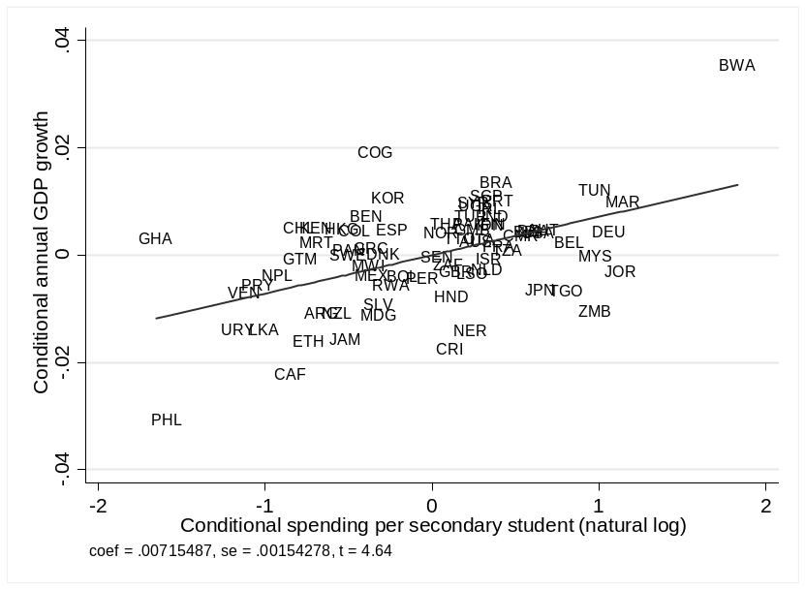

  - Guidance for a country’s policymakers
The preceding sections have identified patterns in the cross-country data relating to the prioritisation of the various sub-sectors of the education sector. Examining where a specific country lies in relation to these patterns can strengthen or challenge prevailing understandings amongst policymakers. In this section, South Africa’s position is examined, partly with a view to checking the utility of what has been presented above. However, considerable attention also goes towards examining the reliability of the UIS statistics and recalculating these statistics where necessary. In fact, it will be seen that getting the basic facts, or accounting, right, and possibly arguing that firmly entrenched statistics are seriously incorrect, can represent a large portion of the work that must be done by anyone wishing to advice policymakers.
Gustafsson (2012b) points to serious problems in the way the UIS and others have calculated the gross enrolment ratio (GER) values for South Africa, relating to the incomparability of official population estimates and official enrolment estimates. The suggestion made is that accurate GER values should be calculated from one source, household survey data. This calculation is done below. Moreover, key spending values are recalculated, and here too it is found that the UIS values are problematic. All this raises the question of the extent to which UIS values in other countries are reliable, and thus the validity of the kind of cross-country analysis presented in previous sections. In defence of the UIS data it can be argued that the patterns seen in the previous sections seem sufficiently non-random and intuitively right to warrant faith in the data. One can assume that to some degree country-specific errors are randomly distributed and thus cancel each other out, producing aggregates that are usable. Gustafsson (2012: 6), in comparing GER-type errors in South Africa to those found elsewhere, concludes that those for South Africa are particularly large, which also counts in favour of the overall reliability of the UIS statistics.
Trends for all the UIS variables out of the 11 UIS variables that have received attention above and for which values existed for South Africa, are shown in the next three graphs.
Figure 58: South Africa gross enrolment ratio values
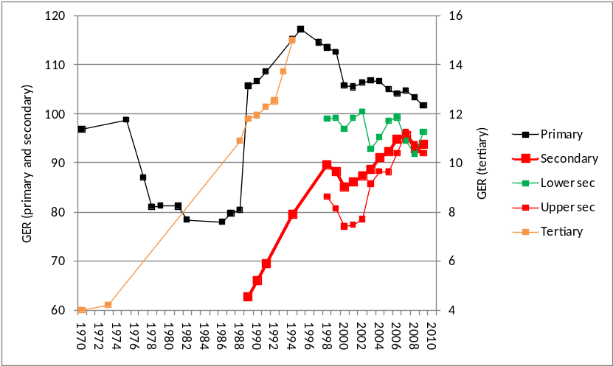
Source: Own calculations using data from UIS online querying facility, downloads from September 2012.

According to the above graph, 1989 is a watershed year in terms of the quality and availability of GER values. Before that year there are hardly any tertiary GER data points, there are no secondary GER values, and the primary GER trend looks suspicious. One might have expected some negative effect on primary enrolments of the civil unrest occurring in the 1976 and 1988 period, but the likelihood that these troubles cut primary enrolments by a fifth, as suggested by the graph, and that a recovery should have occurred so quickly, between 1988 and 1989, seems unlikely. In fact, a historical enrolment dataset compiled by Crouch (1999), using a variety of pre-1994 sources, points to a steady increase in absolute primary level enrolment numbers between 1981 and 1994, with increases each year in the range of 0.4% and 6.6%. The precipitous dip in primary enrolments after 1976 seen in the above graph is moreover not seen in the form of a kink in the later attainment statistics amongst adults in Louw, Van der Berg and Yu (2006: 30) or Case and Deaton (1999: 1055). The large dip in the primary GER seen in the UIS dataset for South Africa is almost certainly nothing more than a manifestation of the serious measurement problems applicable to South Africa during the pre-1994 period, when officially the country was considered to be split into several independent republics and data collection processes were fragmented. The rather sharp decline in the primary GER for the post-1994 period seen in the above graph is also deceptive. This matter receives some attention below.
An analysis using fresh data presented below will indicate that the primary and secondary spending ratios seen in Figure 59 are more or less right, though the real trend is almost certainly less erratic than what is seen in the UIS data.
Figure 59: South Africa UIS education expenditure indicator values
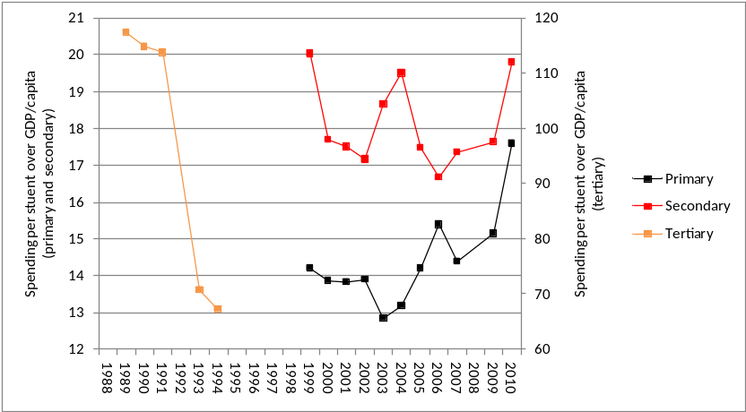
Source: Own calculations using data from UIS online querying facility, downloads from September 2012.

The proportion of secondary level enrolments that is vocational has grown over the long term, according to the following graph, though the trend since around 2000 has been uneven. This UIS pattern agrees roughly with what is seen in official publications (for instance South Africa: Department of Higher Education and Training, 2013), though here the absence of UIS metadata poses a serious problem as vocational enrolment statistics can be derived in two very different ways. They can represent actual people enrolled at some point in the year (headcounts) or such people converted to full-time equivalent students. It appears as if the UIS statistic reflected below is derived from headcounts and not full-time equivalent students.
Figure 60: South Africa UIS vocational secondary education enrolment values
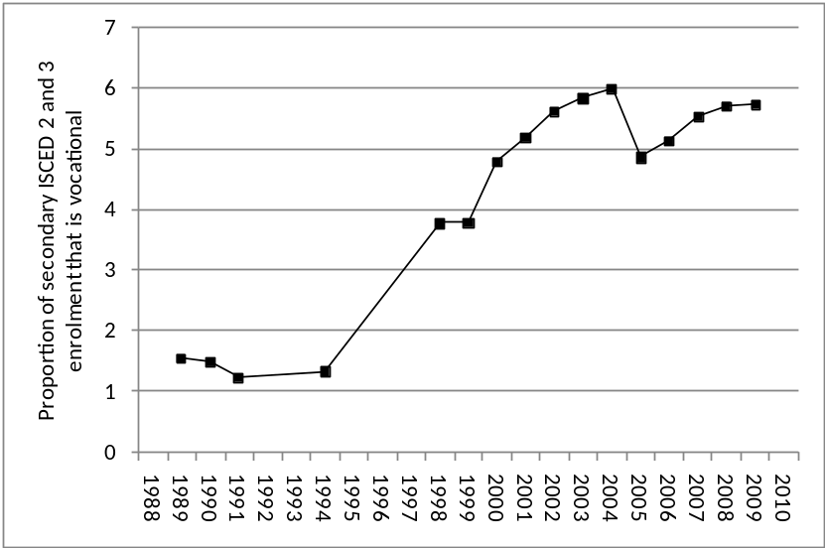
Source: Own calculations using data from UIS online querying facility, downloads from September 2012.

The enrolment and spending indicator values for all three levels of the education system in South Africa are now recalculated, going back to around the middle of the first decade of the 21st century. For education planners to understand whether current trends are moving in the right direction, data for just over five years are generally enough. Gustafsson (2012b) points out that dividing official enrolment values by population values results in under-estimates of the GER because population estimates appear to be over-estimated by around 14%. Table 36 presents what can be considered more or less accurate GER figures, derived from just one data source, the sample-based General Household Surveys (GHS) (Statistics South Africa, 2012), meaning the problem of a numerator that is not comparable to a denominator is avoided. The Table 36 GER values are indeed 5 to 10 points higher than the GER values of the UIS seen in Figure 58. The age ranges and school grades used for the Table 36 ratios are the same as those used by the UIS.
Table 36: South African gross enrolment ratios from household data
 | 2003 | 2006 | 2009 | 2010 | 2011 | 2006-2011 slope
Primary (7-13) | 112 | 115 | 115 | 115 | 116 | 0.1
Lower secondary (14-15) | 107 | 104 | 109 | 111 | 115 | 2.2
Upper secondary (16-18) | 93 | 99 | 95 | 93 | 97 | -0.7
Secondary (14-18) | 99 | 101 | 101 | 100 | 105 | 0.4
Tertiary (19-23) | 15 | 13 | 14 | 13 | 15 | 0.2
Note: Values in brackets refer to the age range used for the denominator.
Source: Own calculations using General Household Survey datasets (Statistics South Africa, 2012).

From 2009, the GHS started asking what grade each child was attending. Responses to this question were used in the calculation. However, before 2009 the grade attended had to be derived indirectly through responses to two questions, firstly what the highest grade was that the child had successfully completed and, secondly, whether the child was enrolled in a school. This would result in an inflation of a few points in the pre-2009 GER values at the primary level, due to ambiguities in the data in relation to pre-schooling. Even if one takes these measurement problems into account, it remains clear that the GER values for South Africa are in fact higher than what is reflected in the UIS database, and that with the exception of the lower secondary level, they have been relatively stable in recent years. The lower secondary level (grades 8 to 9) ratio has seen an average annual increase of around 2.2% in the 2003 to 2011 period.
The next table presents statistics needed to calculate fresh spending ratios for South Africa, for the years 2006, 2009 and 2012. The process of obtaining these ratios illustrates the complexity of the exercise and, by implication, how easy it is for spending ratios in the UIS data collection system to be corrupted. Non-bold values in Table 37 are source values used to calculate the values in bold. GDP per capita values in the table are actually drawn from two different sources: GDP from official Statistics South Africa (Stats SA) reports is divided by official Stats SA mid-year population estimates (Statistics South Africa, 2010, Statistics South Africa, 2011, and so on). Total current spending on schools is taken from National Treasury publications, and only figures for the budget programme dealing with public ordinary schools are considered (http://www.treasury.gov.za). Thus the effect of public funding on private school students, which would diminish the average spending per student (by around 2% only), and the effect of public funding on special needs students, which would increase average spending per student slightly, are ignored. The strong possibility that some pre-school spending, or spending on grade R, a grade below grade 1, is erroneously included in the budget programme on public ordinary schools, and not in the separate budget programme created for grade R, is a further complexity that is not explicitly dealt with. Moreover, it is assumed, for instance, that for the 2006 school year, which lasts from January to December, one can use figures for the 2006/07 financial year, which lasts from April 2006 to March 2007.
Spending on the primary level is seldom accurately separated from spending on the secondary level partly because per student spending on these two levels is rather similar and is driven by the same set of policies, and partly because there are many schools with a mix of primary grades (1 to 7) and secondary grades (8 to 12). For Table 37 a ratio of 1.12 for per student spending at the secondary level, relative to the primary level, was used, based on analysis put forward in an unpublished report of the national education authorities (South Africa: Department of Education, 2006). This report contains what is perhaps the most in-depth analysis available of how costs at the secondary and primary levels differ, using to a large extent differences seen in the payroll data and differences in pupil/teacher ratios. Though the same set of policies governs primary and secondary school funding, secondary schools tend to be funded somewhat more, in per student terms, because of the way the teacher allocation norms treat the secondary school curriculum and because secondary schools tend to be larger, which helps them secure more publicly paid administrative and support staff, and higher salaries for school principals.
Table 37: Calculating South African per student spending ratios
 | 2006 | 2009 | 2012 | 2006-2012 slope
GDP per capita at current prices (Rand) | 37,295 | 48,791 | 63,115
Total current spending on schools (million R) | 59,934 | 93,527 | 121,438
Enrolment primary (grades 1 to 7) (thous.) | 7,078 | 6,917 | 6,744
Enrolment secondary (grades 8 to 12) (thous.) | 4,400 | 4,263 | 4,406
Ratio of secondary to primary unit cost | 1.12 | 1.12 | 1.12
Per student spending primary | 5,000 | 8,012 | 10,415
Ratio to GDP per capita | 0.13 | 0.16 | 0.17 | 0.005
Per student spending secondary | 5,579 | 8,940 | 11,621
Ratio to GDP per capita | 0.15 | 0.18 | 0.18 | 0.006
Subsidies to universities (Rm) | 10,986 | 15,297 | 20,903
Subsidies to university students (Rm) | 926 | 1,444 | 3,875
Enrolment universities | 741,000 | 837,779 | 909,716
Per student spending university | 16,076 | 19,983 | 27,237
Ratio to GDP per capita | 0.43 | 0.41 | 0.43 | 0.000

Turning to public spending per student at the tertiary level, here much of the complexity relates to public funding for student loans and bursaries occurring through the National Student Financial Aid Scheme (NSFAS), captured in the line ‘Subsidies to university students’ in Table 37. As for pre-tertiary education, a key source for tertiary spending are the publications of National Treasury. This source is used for the fairly straightforward line ‘Subsidies to universities’. A problem with the National Treasury figures for subsidies to students is that these figures, expressed as transfers to NSFAS, do not distinguish between funds that flow to tertiary or university students, and funds that flow to non-tertiary vocational college students. By 2012, the proportion of NSFAS spending flowing to college students seemed to have reached 25% (South Africa: Financial and Fiscal Commission, 2012: 45; South Africa: National Student Financial Aid Scheme, 2012: 53). In 2006 the figure was 0%, and in 2009 around 17%. Though NSFAS is able to provide loans and bursaries in excess of its receipts from National Treasury, as loan repayments get recycled into new subsidies, only the portion of National Treasury’s contribution considered to be flowing to non-college students was counted. The would be in line with the UIS approach of counting only public funding, meaning revenue from private loan repayments should be ignored. The approach followed gives one what is probably the closest one can get to counting just subsidies, and not loans, in the sense that in a context of stable enrolments and prices, the National Treasury contribution would more or less amount to subsidies excluding loan amounts, as loans would be funded by the debt repayments of former students. The sum of the subsidies to universities and subsidies to students lines of Table 37 agrees broadly with other estimates of the total public funding of university students (South Africa: Financial and Fiscal Commission, 2012: 45; De Villiers, 2009). What seems to be the most recent UIS guide on how to calculate several (but not all) the UIS indicators, UNESCO (2003), indicates that the denominator for the tertiary spending ratio should be headcounts and not full-time equivalent students. This is important as if one uses full-time equivalent students, the denominator drops by around 35%, meaning the ratio would rise by around 50% (South Africa: Department of Higher Education and Training, 2013).
The previous two tables present enrolment and spending indicator values for South Africa which we can consider sufficiently reliable for a meaningful comparison to global trends, using the Figure 37 graph. For South Africa, 2009 values are used and global values are on average from 2007, as in Figure . The graph is magnified below to provide a focus on values of relevance for South Africa (ZAF).
Figure 61: Educational level prioritisation in South Africa 2009
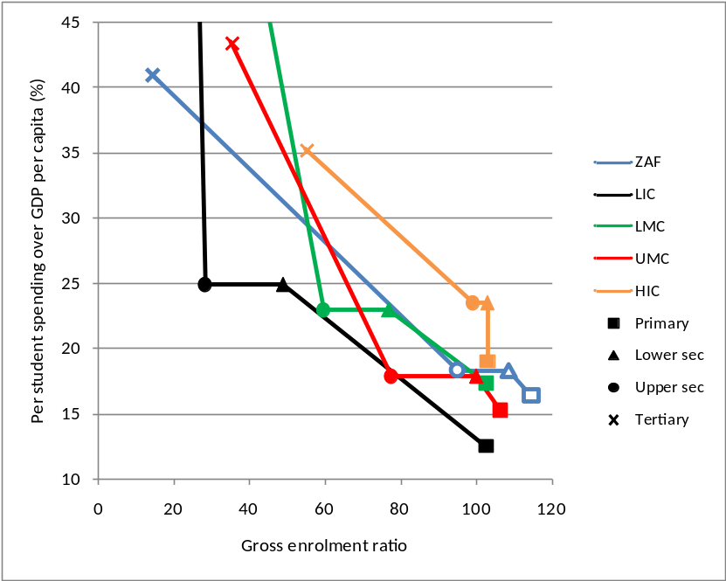
Source: Own calculations using data from UIS online querying facility, downloads from September 2012.
Note: The expenditure levels used for lower and upper secondary are those that apply to secondary schooling as a whole.

The spending levels in South Africa are more or less like those in other upper middle income countries, according to the graph. The graph indicates that South African primary and secondary spending levels are marginally above the average, whilst the tertiary spending level is marginally below. The more interesting comparison relates to enrolments. Here South Africa lies considerably above the average UMC level when it comes to schooling, and considerably below this level when it comes to tertiary enrolments. In fact, the primary and lower secondary GER values for South Africa lie to the right of the corresponding averages of all development categories. At the tertiary level, South Africa’s GER of 14 is closer to the low income average of 9 than the lower middle income average of 25, let alone the upper middle income average of 35.
Figure 62 below offers a more continuous view of the global patterns and South Africa’s position within them. This is a reproduction of Figure 43, meaning development trajectories are depicted not primarily on the basis of income, but on the basis of a factor analysis of the education indicators. South Africa’s actual position is indicated by the solid triangles, whilst the positions one might expect South Africa to be at are indicated with the non-solid triangles. South Africa was not one of the 112 countries for which sufficient UIS data existed for inclusion in the factor analysis, thus South Africa’s expected positions along the curves were calculated by using Figure 42 to translate South Africa’s income value to the z-score discussed earlier.
Figure 62: Average pathways with South African points
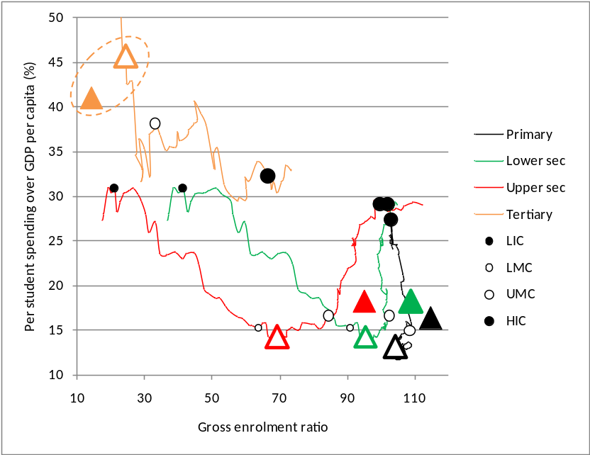
Source: Own calculations using data from UIS online querying facility, downloads from September 2012.
Note: The points labelled ‘LIC’ etc. are positioned where they represent the median z-score per development category produced by the factor analysis.

How might the above graph assist the South African policy debates? It can reinforce the notion that South Africa is at the lower end of the upper middle income category, meaning that a simple comparison to UMC averages can be deceptive. In fact, along several of the curves South Africa is closer to the LMC median point than the UMC median point. But above all the graph underlines a fundamental structural problem with the South African education system, namely that relatively speaking it has over-prioritised schools and under-prioritised tertiary education, both with respect to enrolment numbers and per student spending. To some extent, the Sub-Saharan Africa problem of an under-sized tertiary sector exists in South Africa too, though South Africa does not experience the problem of an extremely high spending ratio. At the tertiary level, spending per student in South Africa seems a bit low. But the key problem is that tertiary enrolments should be around 70% higher than they were in 2009.
In Table 38 below, the global ‘norm’ is represented by the non-solid triangles in Figure 62 above, or where South Africa perhaps should have been in 2009. The question is whether overall this would have implied a more or less costly education system, relative to the actual situation in 2009. We can use the enrolment and spending indicator values to calculate the overall public cost of the education system relative to GDP, if we introduce just one statistic, namely each age-specific population group’s share of the total population. This is provided in the last column. For instance, youths aged 19 to 24, the ages used for the tertiary GER by the UIS, accounted for 10.1% of the total population in 2009. Clearly, South Africa has not achieved a less costly education system by over-prioritising primary and secondary education relatively to tertiary education. Total spending came to 5.3% of GDP in 2009 (if one considers just the main education sub-sectors listed in the table), and it would have come to around 4.4% of GDP had South Africa’s enrolment and spending patterns been closer to global trends. One could use the figures in the table to point out that if a more ‘normal’ degree of prioritisation towards tertiary education were to be achieved in South Africa, this would raise public spending in this level from 0.6% of GDP to 1.1%, but to 1.0% if 2009 per student spending ratios were maintained. To free up the additional 0.5% (or 0.4%) of GDP needed for this, within the existing budgetary envelope, it might be possible to reduce the schooling GERs over time through quality-related efficiency gains, specifically reductions in the primary level GER through less grade repetition. In fact, moving from the actual primary GER of 115 to a more efficient, yet attainable, GER of 104, would free up around 0.3% of GDP, not much less than the percentage of GDP needed to expand the tertiary level. In fact, this type of solution may be missed by policymakers because primary GER values for South Africa published by the UIS, but also others, tend to be under-estimates.
Table 38: Total spending patterns for South Africa
 | Actual |  |  | Global ‘norm’
 | GER | Exp. per cap./ GDP per capita | Total exp./ GDP | GER | Exp. per cap./ GDP per capita | Total exp./ GDP | Fraction of total pop.
Primary | 115 | 16 | 2.8 | 104 | 13 | 2.0 | 0.148
Lower secondary | 109 | 18 | 0.8 | 95 | 14 | 0.6 | 0.043
Upper secondary | 95 | 18 | 1.1 | 69 | 14 | 0.6 | 0.064
Tertiary | 14 | 41 | 0.6 | 24 | 46 | 1.1 | 0.101
Overall | 82 | 18 | 5.3 | 74 | 17 | 4.4 | 0.356
Source: Stats SA mid-year population estimates broken down to single ages as explained in Gustafsson (2012b) were used to calculate the proportions in the final column.

New analysis can provide a needed reinforcement of existing analysis and perceptions, and it can assist in overturning misperceptions and ‘myths’. What contribution may the above analysis make in the case of South Africa? Amongst analysts, the point has been made before that there is an under-prioritisation of post-school education. This is done by, for instance, Gustafsson (2011), using cross-country comparisons but in a manner that differs to what was presented above. Crouch and Vinjevold (2006) have argued that Southern Africa is an unusual region in its combination of high enrolment ratios at the primary and secondary levels and exceptionally poor performance in international tests. They speculate that the region has perhaps over-prioritised enrolment at the cost of quality, a hypothesis that would complement the tertiary under-prioritisation argument, partly because a robust tertiary education sector relies on there being sufficient quality in the schooling sector. The policy documents do reflect a concern with the low levels of tertiary enrolment. For example, as discussed in Part III of the dissertation, the government aims to increase post-school enrolments, including university enrolments, by a factor of 4.7 by 2030. However, this target is unrealistically high and can be considered a reflection of the fact that the necessary planning has not occurred. With respect to the high secondary level enrolment values in South Africa, there is no plan to reduce these, as one might expect. However, there appear to be risks inherent in the policy uncertainty governing this area, and intermittent signals that enrolments should grow even further at this level. A 2009 set of targets released by the Presidency referred to ‘enrolment ratios’ of 95% by 2014. If this was simply taken to mean the gross enrolment ratio, then this 95% had already been reached by 2009 at the upper secondary level (see Table 36). However, in the South African context the target is more likely to have been interpreted as the percentage of youths reaching Grade 12 at school. In 2009, this was around 60%, which could be broken down into around 40% successfully completing Grade 12 and a further 20% participating in the grade but not passing (South Africa: Presidency, 2009: 23; Gustafsson, 2011). A clearer but different target emerges from the 2011 sector plan for basic education, where it is envisaged that by 2019 60% of youths would be successfully completing Grade 12 at a school, whilst the remaining 40% would be achieving something equivalent in the vocational training sub-sector (South Africa: Department of Basic Education, 2011b: 175). The 2012 national development plan, on the other hand, puts forward as a target twelve years of compulsory schooling by 2030 (South Africa: National Planning Commission, 2012: 296). The very strong focus on completing Grade 12, or at least twelve years of education, a commitment which could result in even further growth in the secondary schooling level, needs to be understood against the fact that there is no national qualification below the Grade 12 level, so amongst policymakers and the public there is a sense that someone who has not completed twelve years of schooling is essentially uneducated. This represents an unrealistic and extreme position that ignores the fact that even in some high income countries there are youths who enter the labour market with less than twelve years of schooling. For instance, in recent years around 10% of youths in the United States have completed just grade 11 or a lower grade.
Turning to per student expenditure, the perception that spending is high at the school level relative to what is found in other countries is commonly found in both the analytical and policy texts. For instance, the 2011 sector plan quotes figures indicating that USD PPP spending per secondary student is 2.9 times the level found in Latin America (South Africa: Department of Basic Education, 2011b: 28). If one uses per student spending over GDP per capita, as is done in the above analysis, the figure of 2.9 is reduced to 1.4. Clearly the magnitude of the difference is influenced by the measure one uses. The policy challenge, if one takes into consideration analyses of what drives costs in schools, seems to be to ensure that teacher pay is not allowed to rise uncontrollably and to crowd out other priorities. Moreover, the structure of the teacher pay system needs to become more oriented towards incentivising improved educational outcomes (Gustafsson and Patel, 2009; South Africa: Department of Basic Education, 2011b: 16). One way of explaining to policymakers and teacher unions that there is something wrong with the recent school spending trajectory is to refer to the fact that per student spending over GDP per capita ratios have been rising, for instance by 0.5 points a year for the primary ratio (see last column of Table 37) when the general trend for middle income countries is for these ratios to fall (see Figure 49).
- CONCLUSIONS FOR PART II
Part II of the dissertation is the part most focussed on extracting new findings from the data. In this task, a relatively well-known but arguably under-utilised data source, the country-level education data of the UNESCO Institute for Statistics (UIS), was used. The UIS enrolment data have been used fairly extensively, by for instance Lutz, Cuaresma and Sanderson (2008), to fill in gaps where country-specific household data were not able to provide educational attainment values, but the kind of analysis of cross-sectional and historical enrolment and expenditure trends provided in this part of the dissertation is new. As speculated in section 10.1, a reason why the UIS data have not been subjected to more comprehensive analysis of this nature could be that obtaining a usable dataset off the UIS online data querying facility is cumbersome.
The central question for this part of the dissertation was: What new patterns can be found in the historical country-level enrolment and per student spending data to inform policymakers on how to prioritise the various levels of the education system? It should be emphasised that comprehensive and reliable guidance to policymakers on how to identify and resolve imbalances in the spread of resources and policy emphasis across the levels of the education system has been scarce in the economics and education planning literature, despite the obvious importance of the topic. As will be seen, the patterns observed partly validate understandings policymakers and analysts already held, partly challenge some of these understandings, and to some extent offer a few complete surprises.
That there are in fact sufficiently robust patterns in the UIS data that relate to country development is perhaps most strikingly seen in the factor analysis described in section 10.3. Of the 194 countries with at least one value since 2000 with respect to seven key indicators, four gross enrolment ratios for four levels of the system, and three expenditure values for three levels of the system, 112 countries had all seven values. For these 112 countries, factor analysis allowed for the generation of a single z-score summarising relatively well the trajectory of country development. Four of the variables displayed uniqueness scores indicating particularly strong correlations. This appeared to support the viability of depicting comparable convex or ‘boomerang’ curves, each representing the cross-sectional configuration of enrolment and spending across education levels of a single country or a group of countries (see for instance Figure 61), as well as ‘development routes’ for each level of the education system (see for instance Figure 62). It has been argued that these graphs represent devices that policymakers may find useful for describing and comparing education systems and specifically prioritisation across levels.
The historical analysis presented in section 10.4 has confirmed that there has been a striking increase in enrolments at all education levels in the decades since 1970. This increase clearly exceeds what one may expect in a normal country development trajectory where particular levels of development correspond to particular enrolment patterns. It is this trend which in many ways inspired Pritchett’s (2001: 368) hypothesis of massively inefficient over-enrolment across the world. The analysis presented above found that the enrolment expansion trend clearly holds even when changes in the classification of country development status over time are taken into account. Importantly, the trend has been accompanied by a large fall in per student expenditure relative to GDP per capita, at least at the secondary and tertiary levels, even within specific country development categories. For instance, for middle income countries the average gross enrolment ratio (GER) at the tertiary level more than tripled, whilst per student expenditure relative to GDP per capita was by the 2000s a fifth of what it had been in the 1970s. An attempt was made to disentangle the influence of rising income and the influence of historical forces on enrolment increases and it was found that the surge in secondary level enrolments occurred largely in the 1980s and 1990s, whilst that for tertiary enrolments occurred largely in the 1990s. What the data cannot tell us is what these historical forces were, but one can speculate that changes in technology pushed up the demand for, say, tertiary education, whilst the political emphasis on universalising primary school education would have increased the number of young people demanding secondary and then tertiary education.
The historical trends beg the question of whether the same increases in GDP per capita could have been achieved with fewer structural changes in education, in other words with less expansion of the education system and without falls in per student spending relative to GDP. This question is essentially about the relative strengths of screening effects and productivity enhancement effects. We can be rather certain that the latter effects have occurred, on the basis of the work of for instance Vandenbussche, Aghion and Meghir (2006), discussed in section 9.2 above. But could a large portion of the expansion, perhaps most of it, have been a question of ‘education for show’, or the effect that Pritchett (2001) worried about? It is instructive to keep in mind a few empirically informed magnitudes. The interpretation in section 9.2 of the models of Vandenbussche et al (2006) pointed to an improvement in the growth rate, in terms of per adult output, of 0.1 percentage points arising from a 2 percentage point improvement in tertiary attainment levels amongst adults, from 13% to 15%. Table 30 pointed to expansions in the tertiary GER that would roughly correspond to growth improvements of 1.1 percentage points for middle income countries and 1.9 for high income countries between the 1970s and 2000s. Average annual improvements in GDP per capita between the 1970s and 2000s were slightly negative for high and upper middle income countries, and effectively zero for lower middle income countries, even if one excludes the especially poor growth figures of 2009. These are trends seen in the Penn income data used in the foregoing analysis and obviously ignore the fact that there were some countries that did grow rapidly. Yet at the aggregate level they suggest that much of the enrolment expansion was ‘for show’, though empirical certainty on this matter may never be achieved given data constraints and the complexity of the dynamics at work.
The analysis in Part II focussed partly on whether there were differences in the education trends between faster and slower growing countries within each country development categories. In general, it was found that faster growers prioritised education more in the sense that they had higher gross enrolment ratios and higher levels of per student spending relative to GDP per capita. One exception to this pattern was that amongst less developed countries, more rapid growth was associated with lower values in the per student spending indicator at the tertiary level. In terms of trends over time, the Mingat and Tan (1998: 9) finding, using just cross-sectional data, that there is a large drop in spending on every tertiary student relative to GDP per capita as countries develop was confirmed using longitudinal data, but it was furthermore found that the drop with respect to this spending indicator occurs faster in countries that grow more rapidly. It could be that better governed countries are better at managing unit costs at the tertiary level in a manner that protects the quality of education whilst permitting the enrolment of more students. These countries are thus better at employing a rationalist planning approach as opposed to succumbing to the variety of less rationalist pressures described in section 8 above.
One intriguing finding is the explanatory power that spending on each secondary student in the 1970s, expressed in logged USD PPP terms, has with respect to growth in subsequent years. The semi-Bayesian growth regression of Sala-i-Martin, Doppelhofer and Miller (2004), discussed in depth in Part I of the dissertation, was used to gauge the explanatory power of various education indicators derived from the UIS data. The only indicator that emerged as having a high probability of being included in a growth regression, using the criteria of Sala-i-Martin et al (2004), was the abovementioned secondary school spending indicator. In fact, the inclusion probability of this indicator was considerably higher than the inclusion probability of primary school enrolments in the 1960s, the key education indicator considered by Sala-i-Martin et al (2004). The analysis presented above points to a 50% increase in initial spending per student at the secondary level being associated with a growth improvement of 0.3 percentage points. This finding runs contrary to some other evidence that per student spending has mattered very little for development. For instance, Hanushek and Woessman (2007: 60) make the latter argument strongly, but using OECD data from a smaller set of mainly high income countries. That secondary schooling indicators can display surprisingly strong conditional correlations with growth has also emerged from the analysis by Lutz, Cuaresma and Sanderson (2008), discussed in section 9.2, though the finding here related to the importance of expanding secondary school enrolments. Indicators on secondary enrolments did not emerge as significant predictors in the semi-Bayesian approach used in section 10.5.
A popular perception that Sub-Saharan Africa has over-prioritised primary schooling, relative to other levels of education, is only partially supported by the analysis presented above. What the UIS data show is that although Sub-Saharan Africa did see large increases in its primary level GERs, up to around 2009 countries in the region were still behind other comparable countries with respect to this indicator. At the same time, over the 1970 to 2011 period, the tertiary GER for the region increased by a larger factor than elsewhere, albeit off a low base. In a similar vein, secondary level enrolments grew faster in the region than elsewhere. The ratio of the primary GER to the tertiary GER dropped in Sub-Saharan Africa to a greater degree than it did in other regions. On the other hand, to support future prioritisation of the secondary and tertiary levels in the region, one could point to the fact that whilst by around 2010 Sub-Saharan Africa had caught up to the rest of the world with regard to primary enrolments, its secondary GER values were around half of those found in comparator countries, whilst its tertiary GERs were on average only one-sixth of what one finds in other countries with comparable levels of income.
One matter that was investigated was whether the correlation between country population and spending on each tertiary student suggested high spending was an economy of scale problem. One might expect a country such as Swaziland with a population of around a million and one small university to experience exceptional pressures associated with fixed costs related to, for instance, libraries and small classes in more specialised subjects. Yet the analysis suggested that rather than population, being in Sub-Saharan Africa was the critical factor driving tertiary education unit costs. This finding suggests that a binding constraint on expansions to tertiary enrolments in the region are solvable inefficiencies within the tertiary sector.
Partly in order to test the utility of the graphs and frameworks developed in the analysis, South Africa’s statistics were compared to global trends. One thing this exercise confirmed was the importance of not taking individual country statistics distributed by the UIS at face value, without considering distortions that may have occurred, in particular due to the incomparability of national enrolment and population statistics. Data problems would of course also bias the global statistics, but one hopes that to some extent country-specific errors would cancel each other out, resulting in global patterns that are sufficiently reliable. Moreover, the errors in the South African values appear to be exceptionally large. Recalculated South Africa statistics were used to confirm what a number of policy documents and analyses have said, directly or indirectly, namely that there is an imbalance between relatively low tertiary enrolments and relatively high secondary enrolments in South Africa. The South African policy is perhaps most confusing when it comes to successful completion of Grade 12, with some public targets advocating twelve years of compulsory education and thus an even higher GER at the secondary level, when what is probably needed is better completion rates with the current GER. Put differently, the bottleneck created by insufficient numbers of secondary school graduates ready for university is implicitly said to be best solved through quantitative expansion when qualitative improvements seem more appropriate. The kind of analysis presented above can thus be useful in pointing out to decision-makers that the key problem in South Africa is not one of an insufficient number of secondary school students.
To conclude, whilst the analysis of Part II has not produced an all-encompassing and empirically informed model of how enrolment and spending, by level, evolve in the country development process, it has, one might argue, brought to the fore patterns that would be informative for policymakers and can be used to persuade experts and voters that cross-country data analysis can be useful and does clarify where structural problems lie and what kinds of changes are possible.

The following table provides values from the dataset used for the main analysis above. Countries are classified as low income, lower middle income, upper middle income and high income countries. The values are the means across the various years for which data were available for that country and that variable. The minimum and maximum years, across all variables, are indicated in the last two columns.

Table 39: Levels of education data by country
ISO code | Country | Cat. | GER prim. | GER LSec. | GER USec. | GER sec. | GER tert. | Voc. 2/3 | PSNT | Tert. eng. | Exp. prim. | Exp. sec | Exp. Tert. | GDP cap. | Min. year | Max. year
AFG | Afghanistan | LIC | 45 | 34 | 15 | 16 | 1 | 4 | 27 |  | 11 | 30 | 317 | 728 | 1970 | 2010
BDI | Burundi | LIC | 60 | 21 | 8 | 7 | 1 | 35 |  | 5 | 18 | 115 | 941 | 391 | 1970 | 2010
BEN | Benin | LIC | 73 | 38 | 15 | 17 | 3 | 7 |  | 4 | 12 | 23 | 145 | 1,063 | 1970 | 2010
BFA | Burkina Faso | LIC | 34 | 19 | 7 | 7 | 1 | 11 | 32 | 3 | 27 | 69 | 1,391 | 718 | 1970 | 2011
BGD | Bangladesh | LIC | 71 | 65 | 35 | 33 | 5 | 1 | 5 | 3 | 6 | 13 | 40 | 879 | 1970 | 2010
BTN | Bhutan | LIC | 61 | 60 | 33 | 30 | 4 | 28 | 35 | 13 | 9 | 46 | 222 | 1,933 | 1970 | 2011
CAF | Central African Republic | LIC | 72 | 17 | 8 | 11 | 1 | 8 |  | 4 | 9 | 22 | 446 | 773 | 1970 | 2011
CMR | Cameroon | LIC | 95 | 38 | 22 | 22 | 4 | 23 | 7 | 3 | 7 | 48 | 430 | 1,825 | 1970 | 2010
COD | Democratic Rep. of the Congo | LIC | 85 | 43 | 24 | 23 | 2 | 32 |  |  | 4 | 31 | 362 | 585 | 1970 | 2010
COG | Congo | LIC | 118 | 52 | 23 | 50 | 4 | 10 |  | 2 | 11 | 34 | 618 | 2,033 | 1970 | 2010
COM | Comoros | LIC | 91 | 46 | 27 | 28 | 3 | 1 | 20 |  | 20 | 27 |  | 1,214 | 1970 | 2010
ERI | Eritrea | LIC | 49 | 42 | 19 | 24 | 1 | 1 | 18 | 15 | 11 | 25 | 599 | 737 | 1989 | 2010
ETH | Ethiopia | LIC | 45 | 31 | 10 | 17 | 2 | 3 | 10 | 10 | 19 | 42 | 640 | 453 | 1970 | 2010
GIN | Guinea | LIC | 50 | 32 | 17 | 20 | 3 | 5 |  | 10 | 12 | 33 | 399 | 833 | 1970 | 2010
GMB | Gambia | LIC | 60 | 53 | 46 | 19 | 2 | 7 |  |  | 16 | 30 | 341 | 901 | 1970 | 2010
GNB | Guinea-Bissau | LIC | 70 | 23 | 16 | 11 | 2 | 13 |  |  |  |  |  | 496 | 1970 | 2010
GNQ | Equatorial Guinea | LIC | 121 | 41 | 10 | 24 | 3 | 10 |  |  | 1 | 3 |  | 4,412 | 1970 | 2010
HTI | Haiti | LIC | 75 |  |  | 14 | 1 | 3 |  |  |  |  |  | 1,719 | 1970 | 2009
IND | India | LIC | 91 | 69 | 40 | 41 | 8 | 1 | 5 |  | 11 | 21 | 74 | 1,525 | 1970 | 2010
KEN | Kenya | LIC | 101 | 79 | 31 | 35 | 2 | 2 | 18 | 19 | 17 | 25 | 721 | 1,118 | 1970 | 2009
KGZ | Kyrgyzstan | LIC | 104 | 91 | 73 | 91 | 33 | 6 | 11 | 11 |  | 32 | 24 | 1,764 | 1981 | 2010
KHM | Cambodia | LIC | 134 | 42 | 17 | 28 | 2 | 3 | 18 | 3 | 6 | 8 | 60 | 939 | 1970 | 2010
LBR | Liberia | LIC | 63 | 37 | 28 | 19 | 4 | 9 | 28 | 5 | 9 | 67 | 644 | 1,025 | 1970 | 2009
LSO | Lesotho | LIC | 103 | 45 | 22 | 25 | 2 | 4 | 16 | 1 | 22 | 91 | 1,346 | 928 | 1970 | 2010
MDA | Moldova | LIC | 95 | 91 | 75 | 86 | 34 | 8 | 1 |  | 37 | 39 | 42 | 1,935 | 1981 | 2010
MDG | Madagascar | LIC | 113 | 33 | 13 | 21 | 3 | 5 |  | 7 | 8 | 30 | 346 | 833 | 1970 | 2010
MLI | Mali | LIC | 41 | 34 | 17 | 13 | 2 | 12 |  | 2 | 27 | 69 | 630 | 686 | 1970 | 2011
MMR | Myanmar | LIC | 105 | 52 | 35 | 32 | 5 | 1 |  | 5 | 3 | 7 | 36 |  | 1971 | 2010
MNG | Mongolia | LIC | 100 | 85 | 69 | 76 | 27 | 7 | 4 | 17 | 14 | 19 | 22 | 2,180 | 1970 | 2010
MOZ | Mozambique | LIC | 81 | 21 | 6 | 9 | 1 | 14 |  | 10 | 15 | 85 | 1,409 | 465 | 1970 | 2011
MWI | Malawi | LIC | 93 | 40 | 15 | 21 | 1 | 1 | 79 | 33 | 11 | 33 | 2,029 | 672 | 1970 | 2010
NER | Niger | LIC | 31 | 12 | 4 | 6 | 1 | 4 | 3 | 2 | 32 | 89 | 432 | 578 | 1970 | 2011
NIC | Nicaragua | LIC | 92 | 71 | 50 | 42 | 9 | 13 |  |  | 11 | 17 | 93 | 2,722 | 1970 | 2010
NPL | Nepal | LIC | 85 | 59 | 25 | 28 | 4 | 3 |  | 4 | 13 | 12 | 81 | 883 | 1970 | 2010
RWA | Rwanda | LIC | 90 | 24 | 13 | 15 | 3 | 28 |  |  | 14 | 39 | 1,142 | 768 | 1970 | 2011
SDN | Sudan | LIC | 49 | 43 | 23 | 21 | 2 | 4 |  |  |  |  |  | 1,490 | 1970 | 2009
SLE | Sierra Leone | LIC | 56 | 44 | 26 | 15 | 1 | 5 | 80 | 1 |  |  |  | 883 | 1970 | 2011
SOM | Somalia | LIC | 20 | 10 | 7 | 7 | 2 | 18 |  |  | 46 | 58 | 132 | 671 | 1970 | 2009
TCD | Chad | LIC | 56 | 20 | 11 | 10 | 1 | 5 | 14 |  | 10 | 26 | 294 | 839 | 1970 | 2010
TGO | Togo | LIC | 105 | 56 | 22 | 26 | 2 | 7 |  |  | 10 | 38 | 756 | 1,012 | 1970 | 2010
TJK | Tajikistan | LIC | 97 | 92 | 54 | 85 | 19 | 3 | 20 | 10 |  | 25 | 18 | 1,284 | 1981 | 2010
TLS | Timor-Leste | LIC | 111 | 56 | 38 | 50 | 13 | 5 |  |  |  |  | 84 | 1,132 | 2000 | 2010
TZA | Tanzania | LIC | 77 |  |  | 4 | 1 | 10 |  | 13 | 12 | 94 | 1,092 | 717 | 1970 | 2010
UGA | Uganda | LIC | 82 | 26 | 11 | 12 | 2 | 11 | 18 | 8 | 9 | 123 | 942 | 728 | 1970 | 2010
ZWE | Zimbabwe | LIC | 95 |  |  | 27 | 3 | 2 |  | 12 |  |  | 75 | 328 | 1970 | 2010
AGO | Angola | LMC | 99 | 24 | 14 | 15 | 2 | 16 |  | 9 |  | 42 | 76 | 2,539 | 1970 | 2010
ARM | Armenia | LMC | 99 | 94 | 79 | 90 | 28 | 2 | 27 | 7 | 15 | 20 | 11 | 3,321 | 1986 | 2010
BGR | Bulgaria | LMC | 102 | 87 | 95 | 93 | 31 | 28 | 2 | 21 | 19 | 19 | 27 | 6,182 | 1970 | 2010
BLR | Belarus | LMC | 99 | 104 | 65 | 94 | 51 | 10 | 21 | 26 | 12 | 31 | 23 | 7,654 | 1971 | 2010
BOL | Bolivia | LMC | 105 | 96 | 74 | 65 | 26 | 7 |  | 17 | 14 | 12 | 44 | 3,138 | 1970 | 2009
CIV | Côte d’Ivoire | LMC | 70 | 30 | 15 | 17 | 3 | 10 |  | 9 | 21 | 144 | 624 | 1,511 | 1970 | 2011
CPV | Cape Verde | LMC | 111 | 100 | 67 | 46 | 8 | 13 | 18 | 10 | 17 | 19 | 131 | 1,908 | 1970 | 2010
CUB | Cuba | LMC | 106 | 96 | 80 | 75 | 30 | 29 | 5 | 2 | 34 | 44 | 70 | 8,623 | 1970 | 2011
DJI | Djibouti | LMC | 35 | 27 | 15 | 14 | 2 | 20 | 16 | 6 | 24 | 33 |  | 3,204 | 1970 | 2011
EGY | Egypt | LMC | 83 | 96 | 65 | 58 | 19 | 23 | 8 |  |  | 50 | 129 | 2,824 | 1970 | 2010
FJI | Fiji | LMC | 108 | 99 | 64 | 74 | 5 | 4 | 7 |  | 17 | 19 | 135 | 3,630 | 1970 | 2009
FSM | Micronesia (Federated States of) | LMC | 185 | 100 | 74 | 136 | 19 | 2 |  |  |  |  |  | 3,086 | 1970 | 2009
GEO | Georgia | LMC | 95 | 90 | 70 | 85 | 38 | 4 | 15 | 16 | 15 | 27 | 11 | 3,246 | 1981 | 2010
GHA | Ghana | LMC | 79 | 68 | 26 | 42 | 3 | 4 | 14 | 8 | 10 | 26 | 708 | 897 | 1970 | 2011
GTM | Guatemala | LMC | 84 | 51 | 40 | 28 | 7 | 29 |  | 17 | 8 | 8 | 49 | 5,158 | 1970 | 2010
GUY | Guyana | LMC | 101 | 109 | 64 | 82 | 6 | 7 | 14 | 7 | 13 | 15 | 143 | 2,471 | 1970 | 2010
HND | Honduras | LMC | 103 | 66 | 64 | 32 | 10 | 31 |  | 18 | 12 | 20 | 75 | 3,099 | 1970 | 2010
IDN | Indonesia | LMC | 106 | 79 | 50 | 43 | 9 | 16 |  |  | 12 | 14 | 40 | 2,334 | 1970 | 2010
IRQ | Iraq | LMC | 95 | 55 | 30 | 42 | 10 | 8 | 7 | 14 | 9 | 13 | 107 | 5,814 | 1970 | 2009
JAM | Jamaica | LMC | 100 | 96 | 83 | 71 | 12 | 4 | 54 |  | 12 | 18 | 91 | 7,721 | 1970 | 2010
KAZ | Kazakhstan | LMC | 109 | 99 | 84 | 95 | 39 | 7 | 34 |  |  | 22 | 11 | 7,067 | 1981 | 2011
KIR | Kiribati | LMC | 123 | 88 | 75 | 41 |  | 28 |  |  | 20 | 88 |  | 2,786 | 1970 | 2009
LAO | Laos | LMC | 103 | 50 | 29 | 27 | 4 | 9 | 35 | 8 | 7 | 19 | 81 | 1,208 | 1970 | 2010
LKA | Sri Lanka | LMC | 101 | 100 | 71 | 65 | 3 | 1 |  |  | 9 | 23 | 149 | 2,117 | 1970 | 2010
MAR | Morocco | LMC | 81 | 64 | 31 | 32 | 8 | 5 |  | 5 | 20 | 66 | 165 | 2,338 | 1970 | 2011
MHL | Marshall Islands | LMC | 109 | 109 | 70 | 82 | 16 | 4 |  |  | 23 | 28 | 73 | 7,456 | 1970 | 2011
MRT | Mauritania | LMC | 58 | 24 | 19 | 17 | 3 | 5 | 18 |  | 11 | 29 | 148 | 1,330 | 1970 | 2010
NGA | Nigeria | LMC | 85 | 35 | 29 | 23 | 4 | 15 |  |  |  |  | 2,113 | 1,413 | 1970 | 2010
PAK | Pakistan | LMC | 62 | 40 | 24 | 22 | 3 | 3 | 1 |  | 10 | 23 | 191 | 1,730 | 1970 | 2010
PHL | Philippines | LMC | 109 | 84 | 68 | 69 | 25 |  | 17 | 14 | 9 | 8 | 15 | 2,136 | 1970 | 2009
PNG | Papua New Guinea | LMC | 59 | 27 | 3 | 11 | 2 | 19 |  | 25 | 21 | 116 | 401 | 2,046 | 1970 | 2009
PRY | Paraguay | LMC | 106 | 76 | 51 | 39 | 13 | 8 | 1 |  | 10 | 15 | 45 | 3,353 | 1970 | 2009
PSE | Palestine | LMC | 93 | 92 | 69 | 84 | 34 | 1 | 8 | 7 |  |  |  |  | 1995 | 2010
ROU | Romania | LMC | 101 | 96 | 78 | 84 | 21 | 31 | 10 | 20 | 15 | 14 | 27 | 6,662 | 1970 | 2010
RUS | Russia | LMC | 104 | 87 | 90 | 92 | 53 | 13 | 2 |  |  |  | 12 | 10,773 | 1970 | 2009
SEN | Senegal | LMC | 59 | 27 | 12 | 17 | 4 | 6 |  |  | 15 | 29 | 184 | 1,239 | 1970 | 2010
SLB | Solomon Islands | LMC | 86 | 52 | 15 | 20 |  | 21 |  |  | 10 | 119 |  | 1,578 | 1970 | 2010
SLV | El Salvador | LMC | 98 | 74 | 43 | 43 | 16 | 20 |  | 12 | 8 | 8 | 14 | 4,869 | 1970 | 2010
SRB | Serbia | LMC | 102 | 99 | 81 | 90 | 49 | 36 | 1 | 16 | 58 | 14 | 41 | 8,102 | 1999 | 2010
STP | Sao Tome and Principe | LMC | 134 | 67 | 22 | 37 | 4 | 4 |  |  |  |  |  | 1,211 | 1970 | 2011
SUR | Suriname | LMC | 125 | 87 | 55 | 56 | 8 | 35 |  | 10 |  |  |  | 8,499 | 1970 | 2009
SWZ | Swaziland | LMC | 94 | 55 | 34 | 39 | 3 | 2 | 11 | 5 | 11 | 38 | 351 | 2,662 | 1970 | 2010
SYR | Syria | LMC | 105 | 80 | 31 | 52 | 14 | 6 |  |  | 12 | 20 | 103 | 3,117 | 1970 | 2010
TKM | Turkmenistan | LMC |  |  |  |  | 17 |  |  |  |  |  |  | 4,740 | 1981 | 2009
TON | Tonga | LMC | 113 | 108 | 96 | 97 | 5 | 5 | 33 |  | 13 | 14 | 100 | 5,258 | 1970 | 2009
TUR | Turkey | LMC | 102 | 92 | 73 | 54 | 17 | 21 |  | 13 | 9 | 11 | 57 | 6,959 | 1970 | 2009
UKR | Ukraine | LMC | 104 | 97 | 95 | 95 | 53 | 12 | 7 | 23 |  |  | 34 | 5,045 | 1971 | 2010
UZB | Uzbekistan | LMC | 101 | 95 | 105 | 98 | 13 | 15 |  | 16 |  |  |  | 1,659 | 1981 | 2011
VNM | Vietnam | LMC | 107 | 85 | 54 | 63 | 8 | 4 |  | 20 | 19 | 17 | 61 | 1,218 | 1970 | 2010
VUT | Vanuatu | LMC | 114 | 47 | 31 | 23 | 4 | 20 | 53 |  | 14 | 61 | 176 | 4,820 | 1970 | 2010
WSM | Samoa | LMC | 104 | 100 | 74 | 80 | 4 | 3 | 30 | 5 | 10 | 10 | 188 | 5,041 | 1970 | 2010
YEM | Yemen | LMC | 82 | 51 | 37 | 44 | 8 | 1 | 12 |  |  |  |  | 1,951 | 1989 | 2010
ZMB | Zambia | LMC | 98 | 51 |  | 17 | 2 | 6 |  | 22 | 10 | 96 | 751 | 1,430 | 1970 | 2010
ALB | Albania | UMC | 103 | 99 | 61 | 84 | 11 | 19 |  | 7 | 20 | 6 | 37 | 3,347 | 1970 | 2010
ARG | Argentina | UMC | 109 | 102 | 69 | 69 | 39 | 57 |  | 9 | 8 | 15 | 20 | 8,617 | 1970 | 2009
ATG | Antigua and Barbuda | UMC | 97 | 113 | 83 | 91 | 16 | 5 |  |  | 8 | 12 | 15 | 10,533 | 1970 | 2010
AZE | Azerbaijan | UMC | 101 | 88 | 69 | 84 | 19 | 6 | 49 | 6 | 6 | 16 | 16 | 4,187 | 1981 | 2010
BIH | Bosnia and Herzegovina | UMC | 109 | 101 | 81 | 91 | 35 | 35 |  |  |  |  |  | 4,273 | 1990 | 2010
BLZ | Belize | UMC | 112 | 78 | 51 | 64 | 13 | 3 | 34 |  | 15 | 21 | 32 | 6,438 | 1970 | 2010
BRA | Brazil | UMC | 134 | 118 | 88 | 68 | 12 | 10 |  | 8 | 15 | 14 | 56 | 7,385 | 1970 | 2010
BRB | Barbados | UMC | 106 | 101 | 110 | 93 | 27 | 2 | 26 |  | 17 | 24 | 100 | 20,234 | 1970 | 2010
BWA | Botswana | UMC | 94 | 88 | 59 | 43 | 4 | 11 | 52 |  | 14 | 98 | 877 | 5,312 | 1970 | 2009
CHL | Chile | UMC | 110 | 97 | 81 | 74 | 26 | 20 |  | 21 | 12 | 10 | 44 | 6,942 | 1970 | 2009
CHN | China | UMC | 118 | 90 | 51 | 51 | 8 | 9 | 5 |  | 5 | 22 | 729 | 2,013 | 1970 | 2010
COL | Colombia | UMC | 114 | 89 | 66 | 57 | 17 | 20 | 1 | 29 | 12 | 13 | 34 | 4,938 | 1970 | 2010
CRI | Costa Rica | UMC | 106 | 92 | 56 | 54 | 21 | 19 |  | 15 | 12 | 18 | 62 | 8,247 | 1970 | 2010
CZE | Czech Republic | UMC | 106 | 98 | 85 | 91 | 23 | 40 | 12 | 18 | 18 | 22 | 38 | 17,843 | 1971 | 2009
DMA | Dominica | UMC | 111 | 123 | 80 | 86 | 4 | 8 |  |  | 15 | 14 |  | 3,713 | 1970 | 2010
DOM | Dominican Republic | UMC | 109 | 77 | 64 | 50 | 18 | 6 |  |  | 6 | 5 |  | 5,582 | 1970 | 2010
DZA | Algeria | UMC | 98 | 110 | 54 | 47 | 12 | 8 |  | 9 | 13 | 36 | 331 | 4,900 | 1970 | 2010
ECU | Ecuador | UMC | 114 | 70 | 53 | 53 | 25 | 19 |  | 13 | 4 | 8 |  | 5,036 | 1970 | 2009
EST | Estonia | UMC | 100 | 102 | 94 | 97 | 49 | 20 | 13 | 13 | 20 | 31 | 35 | 11,640 | 1981 | 2009
GAB | Gabon | UMC | 154 | 64 | 31 | 36 | 3 | 21 |  |  |  |  |  | 11,507 | 1970 | 2011
GRD | Grenada | UMC | 112 | 116 | 94 | 82 | 13 | 9 | 23 | 3 | 9 | 10 |  | 7,630 | 1970 | 2010
HUN | Hungary | UMC | 100 | 100 | 94 | 88 | 26 | 25 | 17 | 14 | 30 | 15 | 71 | 11,926 | 1970 | 2009
IRN | Iran | UMC | 101 | 96 | 69 | 64 | 13 | 7 | 31 | 29 | 12 | 17 | 104 | 8,130 | 1970 | 2010
JOR | Jordan | UMC | 104 | 93 | 74 | 76 | 21 | 6 |  | 13 | 14 | 27 | 69 | 3,946 | 1970 | 2010
KNA | Saint Kitts and Nevis | UMC | 104 | 100 | 85 | 87 | 6 | 4 |  |  | 9 | 20 | 77 | 6,976 | 1970 | 2010
LBN | Lebanon | UMC | 106 | 91 | 70 | 67 | 34 | 13 |  | 12 | 14 | 4 | 15 | 13,099 | 1970 | 2010
LBY | Libya | UMC | 121 | 122 | 97 | 67 | 17 | 17 |  | 21 |  |  | 23 | 17,291 | 1971 | 2009
LCA | Saint Lucia | UMC | 117 | 87 | 74 | 55 | 7 | 5 | 53 |  | 17 | 31 | 91 | 8,484 | 1970 | 2010
LTU | Lithuania | UMC | 96 | 98 | 101 | 96 | 49 | 13 | 5 | 19 | 16 | 24 | 31 | 10,636 | 1981 | 2010
LVA | Latvia | UMC | 99 | 96 | 94 | 95 | 42 | 20 | 4 | 11 | 24 | 30 | 27 | 9,710 | 1981 | 2010
MDV | Maldives | UMC | 126 | 104 | 10 | 39 | 13 | 8 | 91 |  | 16 |  |  | 2,162 | 1970 | 2011
MEX | Mexico | UMC | 113 | 105 | 54 | 58 | 16 | 15 |  | 19 | 11 | 15 | 40 | 9,250 | 1970 | 2010
MKD | Macedonia | UMC | 97 | 95 | 72 | 82 | 25 | 27 |  | 17 | 38 | 10 | 61 | 6,439 | 1971 | 2010
MNE | Montenegro | UMC | 114 | 106 | 82 | 94 | 28 | 31 |  |  |  |  |  | 5,736 | 1990 | 2010
MUS | Mauritius | UMC | 103 | 92 | 74 | 59 | 7 | 4 | 22 |  | 12 | 19 | 172 | 5,179 | 1970 | 2010
MYS | Malaysia | UMC | 95 | 93 | 50 | 56 | 17 | 4 | 18 | 22 | 14 | 24 | 130 | 6,631 | 1970 | 2009
NAM | Namibia | UMC | 118 | 80 | 32 | 53 | 6 | 1 | 15 | 3 | 19 | 26 | 116 | 4,210 | 1970 | 2010
OMN | Oman | UMC | 65 | 89 | 73 | 41 | 11 | 6 |  | 9 | 14 | 24 | 116 | 13,863 | 1970 | 2010
PAN | Panama | UMC | 108 | 85 | 54 | 62 | 28 | 29 | 6 | 12 | 11 | 15 | 43 | 5,979 | 1970 | 2010
PER | Peru | UMC | 116 | 96 | 74 | 68 | 24 | 11 | 24 |  | 7 | 10 | 19 | 5,266 | 1970 | 2010
PLW | Palau | UMC | 107 | 101 | 93 | 97 | 39 |  |  |  |  | 9 | 81 | 15,143 | 1980 | 2009
SAU | Saudi Arabia | UMC | 93 | 99 | 90 | 84 | 15 | 4 |  | 7 | 19 | 19 | 165 | 17,603 | 1971 | 2010
SVK | Slovakia | UMC | 99 | 92 | 83 | 88 | 32 | 35 | 2 | 18 | 16 | 14 | 32 | 13,536 | 1987 | 2010
SYC | Seychelles | UMC | 108 | 115 | 99 | 90 |  | 13 |  |  | 16 | 30 |  | 13,379 | 1970 | 2010
THA | Thailand | UMC | 93 | 84 | 58 | 43 | 23 | 17 | 1 | 10 | 13 | 19 | 60 | 4,357 | 1970 | 2011
TTO | Trinidad and Tobago | UMC | 101 | 84 | 76 | 73 | 5 | 2 | 45 | 19 | 13 | 19 | 151 | 13,271 | 1970 | 2010
TUN | Tunisia | UMC | 108 | 106 | 65 | 50 | 13 | 16 | 2 | 10 | 16 | 30 | 128 | 3,776 | 1970 | 2009
URY | Uruguay | UMC | 110 | 109 | 87 | 79 | 31 | 16 |  | 10 | 8 | 10 | 26 | 6,929 | 1970 | 2009
VCT | Saint Vincent and the Grenadines | UMC | 115 | 110 | 73 | 63 | 5 | 8 |  |  | 19 | 20 |  | 3,346 | 1970 | 2010
VEN | Venezuela | UMC | 104 | 83 | 56 | 58 | 27 | 7 |  | 18 | 7 | 8 | 89 | 8,910 | 1970 | 2010
ZAF | South Africa | UMC | 100 | 97 | 86 | 85 | 11 | 4 |  |  | 14 | 18 | 97 | 5,844 | 1970 | 2010
ABW | Aruba | HIC | 112 | 111 | 86 | 96 | 29 | 17 | 4 | 23 | 13 | 19 | 32 |  | 1999 | 2010
AND | Andorra | HIC | 93 | 91 | 70 | 60 | 8 | 7 | 43 |  | 12 | 11 | 28 |  | 1971 | 2010
ANT | Netherlands Antilles | HIC | 139 | 122 | 69 | 99 | 23 | 40 | 11 | 33 |  |  |  |  | 1972 | 2002
ARE | UAE | HIC | 97 | 94 | 76 | 60 | 9 | 2 |  |  | 5 | 7 | 21 | 41,971 | 1971 | 2009
AUS | Australia | HIC | 105 | 115 | 198 | 139 | 46 | 39 | 15 | 11 | 17 | 16 | 41 | 27,412 | 1970 | 2010
AUT | Austria | HIC | 101 | 102 | 96 | 98 | 35 | 39 | 20 | 14 | 20 | 26 | 50 | 27,155 | 1970 | 2010
BEL | Belgium | HIC | 103 | 137 | 126 | 108 | 40 | 45 | 9 | 11 | 17 | 29 | 40 | 25,607 | 1970 | 2009
BHR | Bahrain | HIC | 110 | 107 | 95 | 86 | 9 | 14 |  | 8 | 15 | 16 |  | 22,772 | 1970 | 2010
BHS | Bahamas | HIC | 102 | 93 | 85 | 91 | 19 | 6 |  |  |  |  |  | 21,281 | 1970 | 2010
BMU | Bermuda | HIC | 99 | 91 | 71 | 84 | 16 | 6 |  | 12 | 11 | 16 | 28 | 35,302 | 1970 | 2010
BRN | Brunei Darussalam | HIC | 118 | 119 | 78 | 78 | 9 | 6 | 1 | 6 | 6 | 18 | 142 | 62,215 | 1970 | 2010
CAN | Canada | HIC | 101 | 99 | 106 | 98 | 77 |  | 22 | 10 |  |  | 35 | 27,621 | 1970 | 2009
CHE | Switzerland | HIC | 93 | 111 | 83 | 96 | 28 | 35 | 11 | 14 | 24 | 30 | 56 | 32,597 | 1970 | 2010
CYM | Cayman Islands | HIC | 102 | 93 | 84 | 89 | 21 |  | 8 | 8 |  |  |  |  | 1972 | 2008
CYP | Cyprus | HIC | 100 | 99 | 94 | 96 | 29 | 9 |  | 6 | 17 | 26 | 46 | 12,797 | 1970 | 2010
DEU | Germany | HIC | 102 | 101 | 99 | 101 | 41 | 24 |  |  | 13 | 27 | 39 | 25,318 | 1970 | 2010
DNK | Denmark | HIC | 99 | 120 | 126 | 113 | 43 | 28 | 1 | 10 | 32 | 30 | 60 | 26,613 | 1970 | 2009
ESP | Spain | HIC | 108 | 109 | 127 | 99 | 39 | 20 | 8 | 17 | 15 | 18 | 24 | 19,986 | 1970 | 2010
FIN | Finland | HIC | 98 | 101 | 132 | 110 | 54 | 28 |  | 26 | 22 | 26 | 42 | 23,027 | 1970 | 2010
FRA | France | HIC | 108 | 108 | 113 | 97 | 39 | 23 | 1 | 13 | 15 | 25 | 33 | 24,415 | 1970 | 2010
GBR | United Kingdom | HIC | 104 | 101 | 102 | 91 | 36 | 12 | 0 | 9 | 16 | 26 | 57 | 24,504 | 1970 | 2009
GRC | Greece | HIC | 100 | 98 | 95 | 88 | 36 | 17 | 9 | 15 | 7 | 12 | 26 | 19,085 | 1970 | 2009
HKG | Hong Kong | HIC | 104 | 97 | 69 | 66 | 22 | 5 | 17 | 16 | 10 | 13 | 56 | 21,337 | 1970 | 2010
HRV | Croatia | HIC | 92 | 97 | 83 | 88 | 33 | 37 |  | 17 |  |  | 31 | 10,749 | 1981 | 2010
IRL | Ireland | HIC | 103 | 102 | 121 | 100 | 33 | 11 | 23 | 11 | 13 | 22 | 47 | 20,696 | 1970 | 2010
ISL | Iceland | HIC | 99 | 99 | 118 | 97 | 34 | 22 | 2 | 7 | 23 | 20 | 33 | 27,703 | 1970 | 2009
ISR | Israel | HIC | 102 | 97 | 110 | 91 | 40 | 22 | 4 | 18 | 21 | 22 | 45 | 18,797 | 1970 | 2009
ITA | Italy | HIC | 102 | 106 | 92 | 82 | 38 | 35 | 2 | 16 | 20 | 24 | 26 | 23,342 | 1970 | 2010
JPN | Japan | HIC | 101 | 102 | 101 | 97 | 37 | 14 | 0 | 17 | 20 | 21 | 26 | 25,594 | 1970 | 2010
KOR | Korea | HIC | 104 | 100 | 96 | 85 | 47 | 17 |  | 31 | 15 | 15 | 18 | 12,193 | 1970 | 2010
KWT | Kuwait | HIC | 99 | 108 | 102 | 84 | 14 | 2 | 30 |  | 21 | 11 | 103 | 40,968 | 1971 | 2009
LUX | Luxembourg | HIC | 97 | 107 | 87 | 77 | 5 | 47 | 26 | 12 | 24 | 25 | 84 | 45,205 | 1970 | 2009
MAC | Macao | HIC | 93 | 109 | 73 | 65 | 44 | 12 |  | 2 | 8 | 11 | 28 | 21,424 | 1970 | 2010
MCO | Monaco | HIC |  |  |  |  |  | 19 |  |  | 3 | 7 |  |  | 1971 | 2010
MLT | Malta | HIC | 104 | 97 | 85 | 81 | 14 | 16 | 8 | 8 | 11 | 20 | 93 | 13,363 | 1970 | 2010
NLD | Netherlands | HIC | 103 | 131 | 112 | 110 | 41 | 44 | 2 | 9 | 16 | 24 | 62 | 28,980 | 1970 | 2010
NOR | Norway | HIC | 100 | 99 | 130 | 103 | 46 | 28 | 3 | 7 | 29 | 22 | 45 | 34,047 | 1970 | 2010
NZL | New Zealand | HIC | 103 | 103 | 135 | 98 | 48 | 6 | 15 | 7 | 16 | 17 | 41 | 20,945 | 1970 | 2010
POL | Poland | HIC | 100 | 99 | 101 | 89 | 32 | 42 | 7 | 14 | 24 | 21 | 28 | 9,594 | 1970 | 2009
PRI | Puerto Rico | HIC | 108 | 89 | 78 | 83 | 79 |  | 21 |  | 31 |  | 66 | 17,799 | 1970 | 2010
PRT | Portugal | HIC | 119 | 114 | 93 | 78 | 29 | 18 | 1 | 21 | 16 | 23 | 35 | 14,258 | 1970 | 2009
QAT | Qatar | HIC | 110 | 100 | 80 | 77 | 17 | 3 |  | 4 | 8 | 15 | 30 | 73,367 | 1971 | 2010
SGP | Singapore | HIC |  |  |  |  |  | 9 | 36 | 29 | 8 | 14 | 56 | 24,725 | 1970 | 2010
SMR | San Marino | HIC | 94 | 97 | 96 | 96 |  | 14 | 53 | 15 | 23 | 22 |  |  | 1975 | 2010
SVN | Slovenia | HIC | 100 | 96 | 102 | 92 | 43 | 38 | 1 | 17 | 23 | 24 | 33 | 19,190 | 1981 | 2009
SWE | Sweden | HIC | 101 | 106 | 142 | 104 | 45 | 31 | 3 | 17 | 30 | 25 | 48 | 26,345 | 1970 | 2010
TWN | Taiwan | HIC |  |  |  |  |  |  |  |  |  |  |  | 14,823 | 1970 | 2009
USA | United States | HIC | 98 | 102 | 89 | 92 | 68 |  | 5 | 7 | 21 | 23 | 24 | 31,449 | 1970 | 2010

The term ‘option value’ is typically used to explain why governments invest in or maintain environmental or public assets which are not needed currently, but which are likely to be needed in future. McMahon (1982) and Burger and Teal (2013) are examples of economists who have used the term in the context of education investment choices.
The details of the growth regression appear in a separate technical appendix.
http://data.worldbank.org/indicator/SE.TER.ENRR.
Of course there must be enough observations on either side of the value within the sorted independent variable to fulfil the 0.8 condition. In fact, below the 40th percentile of the independent variable and above the 60th percentile, fewer than 80% of observations will be used in the local regression.
Specifically, 126 possible values per country were considered, as there were three indicators and 42 years. If no more than 25 values of the 126 were missing, the country was included in the calculation (25 being 20% of 126).
The threshold was a PIP, or posterior inclusion probability, of 0.097, derived by dividing an assumed 7 variables for an optimum model by the actual 72 explanatory variables used in the BACE process, the 72 being comprised of 67 original SDM variables and the five new education ones. The PIP refers to the probability that the variable in question would be included in the optimum growth regression.
In the original SDM model, the PIP for the primary schooling variable was 0.796, against 0.133 in the results shown here.
An anomaly that applies to very few countries is found if one compares one of the trends, that for tertiary GER in Figure 58, to several issues of the Global monitoring report produced by UNESCO (for instance UNESCO, 2005). Whilst the UIS data described in section 10.1, and downloaded in 2012 off the UIS website, contain no tertiary GER values for South Africa beyond 1994, the UNESCO reports do have post-1994 values, though the Global monitoring report is supposed to be based on the same UIS data source as that used for the previous sections, and in the case of virtually all countries the reports do mirror the online data exactly. Specifically, the Global monitoring report issues for the years 2003 to 2010 all have recent tertiary GER values for South Africa (though the 2011 and 2012 reports have no tertiary GER statistics at all, for South Africa or any other country). The tertiary GER values for South Africa published in the UNESCO reports are in line with figures presented below, for instance 15.2 for 2000 and 15 for 2007. South Africa is not the only country where this strange gap in the UIS data occurs with respect to the tertiary GER, yet this problem seems highly unusual. An analysis of the 2007 tertiary GER values published in the 2010 Global monitoring report reveals that only Ecuador displays a similar anomaly of a value in the report, but not the UIS database. One could speculate that statistics were not submitted by the South African government to UNESCO through the usual route and that UNESCO, realising the importance of South Africa, then used publicly available reports to construct the GER values. Such patching of the data would be relatively easy. However, if one considers that a few very important countries, with much publicly available data, notably Germany and Singapore, have missing tertiary GER values for recent years in both the Global monitoring report and the UIS database, it seems curious that UNESCO should produce a special patch for South Africa outside the normal data collection procedures. The absence of proper metadata reports for the UIS data, of the kind one finds for the Penn income data, obviously makes it difficult to resolve questions of this kind. The answer is probably only obtainable by interviewing UIS staff.
The problem in relation to South Africa’s tertiary GER discussed in the previous footnote does not apply in the case of the tertiary spending ratio, though here too there are no post-1994 values. The Global monitoring report has never published any tertiary spending statistics, for any country, so here it seems clear that what is in the online database represents all the data there is.
If a child had successfully completed grade 2 and was currently enrolled in a school, it was assumed the child was attending grade 3. The indirect approach could also be followed in the case of the 2009 data and if this was done, the secondary GER would be 100, against 101 if the direct method were used. At the primary level, however, the two approaches yielded more different ratios: 119 if the indirect approach was used and 115 in the case of the direct approach. This is not surprising if one considers the problems posed by the indirect approach when grade 1 enrolments are calculated. The approach dictates that a child enrolled in a school and with a response to highest grade attained being ‘no schooling’, would be considered a grade 1 pupil, but this child may also be enrolled at a level below grade 1 in an institution considered a school by the respondent, even if the strict definition would be a pre-school or a crèche. Grade 1 enrolments, and hence the primary GER, are thus over-estimated if the indirect approach is used, though this problem would have been smaller in, say, 2003 than 2009 as enrolments below grade 1 would have been lower in 2003 than in 2009.
The possibility that the inaccuracies in the latter figures, discussed above, cause inaccurate GDP per capita figures is not be discussed here, as this would be a complex matter beyond the scope of this dissertation
National Treasury publications do in fact report different spending figures for the primary and secondary levels, within two sub-programmes falling under the public ordinary schools programme, but this is largely done to satisfy International Monetary Fund reporting demands, not because this breakdown is used by local analysts. In fact, some basic analysis, by province, of the published primary and secondary spending values against official enrolments will reveal that there must be serious inaccuracies in this split of the public ordinary schools totals.
One calculation that was not done was to remove the public spending associated with capital investments from overall spending values, to produce recurrent spending figures, the ideal for the indicator according to UNESCO (2003). No analyst appears to have done this and doing this would involve examining the financial records of all the individual universities.
Specifically, a table available on the United States Census Bureau site at http://www.census.gov/hhes/socdemo/education/ indicates that for several age groups between 25 and 39 around 10% of the population had completed grade 11 or a lower grade and nothing else in 2012 (viewed October 2013).

